# INTRODUCTION

Welcome to Gym Trainer Website: Your Ultimate Fitness Destination"!

At GTW, we believe that fitness is not just a goal, but a way of life. We are dedicated to helping individuals of all ages and fitness levels embrace a healthier lifestyle, unlock their full potential, and achieve their fitness goals. Our website serves as an online hub for fitness enthusiasts, offering a wealth of resources, personalized training programs, and expert guidance to empower our users on their fitness journey.

Here are some key features you can expect to find on our website:

Comprehensive Exercise Guides: We offer a wide range of exercise guides catering to different fitness levels and goals. Whether you're interested in strength training, cardiovascular exercises, flexibility routines, or specialized workouts, our guides provide detailed instructions, proper form techniques, and tips to maximize your results.

Additional Resources: We may offer additional resources such as e-books, video tutorials, or podcasts to further enhance your fitness knowledge and provide you with diverse perspectives on health and wellness. Home Page: The home page serves as your gateway to the world of fitness on our website. It provides an overview of our key features, highlights recent articles or success stories, and showcases any ongoing promotions or challenges.

Exercise Library: Our exercise library is a vast collection of workout guides and routines. It covers a wide range of exercises, including strength training, cardiovascular workouts, flexibility exercises, and more. Each exercise is accompanied by detailed instructions, images, and videos to ensure proper form and technique.

Workout Plans: We offer pre-designed workout plans that cater to specific goals, such as weight loss, muscle building, or general fitness. These plans provide a structured approach to your workouts, taking into account your fitness level and preferences. They include a variety of exercises, rep ranges, and training frequencies to keep you engaged and motivated.

Customizable Plans: In addition to our pre-designed plans, we offer the flexibility to create personalized workout plans. You can input your specific goals, fitness level, available equipment, and time constraints, and our platform will generate a tailored plan to suit your needs.

Expert Advice and Insights: Access insightful articles, interviews, and podcasts featuring renowned fitness experts, athletes, and health professionals through YouTube. Learn from their experiences, get expert advice, and stay up to date with the latest trends and research in the fitness industry.

Community and Support: Connect with a vibrant community of fitness enthusiasts, share your progress, and seek support from like-minded individuals. Engage in discussions, ask questions, and find motivation in the collective journey towards better health.

We strive to be your go-to resource for all things fitness-related. Whether you're seeking guidance on exercise routines, or a supportive community, our website aims to empower you to reach your fitness goals and live a healthier, happier life.

We are thrilled to be part of your fitness journey and look forward to helping you lead a healthier, happier, and more fulfilling life. Get started today and unlock your true potential with our fitness resources and guidance. Remember, every small step counts, and together we can achieve greatness!

**1.1 BACKGROUND:**

Gym Trainer Website Philosophy:

GTW philosophy revolves around three core principles:

* Personalized Approach: We understand that each individual is unique, with distinct fitness goals, preferences, and limitations. GTW embraces a personalized approach, tailoring fitness programs and resources to suit the specific needs of our users. Whether you are a beginner starting your fitness journey or an experienced athlete looking to reach new heights, we have the tools and expertise to guide you towards success.
* Knowledge and Expertise: At GTW, we prioritize the quality and accuracy of the information we provide. Our team of certified trainers and experts regularly update our content to reflect the latest research, industry trends, and best practices. We strive to empower our users with knowledge, debunking fitness myths, and offering evidence-based guidance to help them make informed choices.
* Community and Support: GTW fosters a strong sense of community, where individuals can connect, share their experiences, and find support. We believe that accountability and motivation are crucial for long-term success. Through our online forums, social media platforms, and interactive features, users can engage with like-minded individuals, participate in challenges, and celebrate their achievements together.

Whether you're looking to transform your physique, improve your athletic performance, or simply embrace a healthier lifestyle, Gym Trainer Website is your trusted companion on your fitness journey. Join our vibrant community today and unlock your full fitness potential!

**1.2 PURPOSE:**

The purpose of a fitness website can vary depending on the specific goals and target audience of the website. However, the general purpose of a fitness website is to provide valuable information, resources, and support related to fitness, health, and wellness. Here are some common purposes of a fitness website:

1. Education and Information: A fitness website serves as a platform to educate visitors about various fitness-related topics, such as exercise techniques, nutrition, workout plans, injury prevention, and overall wellness. It provides informative articles, blog posts, videos, and tutorials to help individuals make informed decisions about their fitness journey.
2. Personalized Training Programs: Many fitness websites offer personalized training programs or fitness challenges to cater to the specific needs and goals of individuals. These programs may include workout routines, meal plans, and tracking tools to help users stay motivated and achieve their desired results.
3. Motivation and Inspiration: A fitness website often aims to inspire and motivate visitors by sharing success stories, transformation photos, and motivational content. It creates a positive and supportive environment that encourages individuals to pursue their fitness goals and overcome challenges.
4. Community and Support: Fitness websites often include community features such as forums, social media groups, or interactive platforms where users can connect, share experiences, seek advice, and provide support to one another. This sense of community helps individuals stay accountable, motivated, and connected with like-minded individuals on their fitness journey.
5. Expert Guidance: Fitness websites may have certified trainers, nutritionists, or wellness experts associated with them. These professionals can provide expert guidance, answer questions, and offer personalized advice through blog posts, videos, or even online coaching services.
6. Product Recommendations and Reviews: Many fitness websites include product recommendations and reviews for fitness equipment, workout apparel, supplements, and other related products. This helps users make informed purchasing decisions based on expert opinions and user experiences.
7. Events and Challenges: Fitness websites may organize or promote fitness events, challenges, or competitions to engage their audience and encourage participation. These events can range from virtual races, fitness challenges, or workshops conducted by fitness experts.

Overall, the purpose of a fitness website is to empower individuals to lead healthier lives, provide them with the necessary tools and knowledge to achieve their fitness goals, and foster a supportive community that motivates and inspires them along the way.

**1.3 OBJECTIVE:**

The objective of a fitness website is to create a comprehensive online platform that serves as a go-to resource for individuals seeking to improve their fitness, health, and overall well-being. The website aims to fulfill the following objectives:

1. Inform and Educate: The primary objective of a fitness website is to provide accurate, up-to-date, and reliable information about fitness-related topics. It aims to educate visitors on various aspects of fitness, including exercise techniques, nutrition, lifestyle choices, and mental well-being. By offering informative articles, videos, and tutorials, the website seeks to empower individuals with knowledge and enable them to make informed decisions about their fitness journey.
2. Support and Motivate: The website aims to provide a supportive and motivating environment for individuals to pursue their fitness goals. It aims to inspire visitors by sharing success stories, transformation photos, and motivational content. By fostering a sense of community, the website encourages users to connect with like-minded individuals, share experiences, seek advice, and provide support to one another.
3. Personalization and Guidance: A fitness website may offer personalized training programs, meal plans, and guidance to cater to the specific needs and goals of individuals. It aims to provide customized recommendations based on the user's fitness level, preferences, and limitations. By offering expert guidance and coaching services, the website helps individuals stay on track and achieve optimal results.
4. Engage and Interact: The objective of a fitness website is to engage visitors through interactive features, such as forums, social media platforms, and challenges. It encourages users to actively participate, share their progress, seek advice, and celebrate their achievements. The website aims to create a vibrant community where individuals can connect, interact, and support each other on their fitness journey.
5. Promote Products and Services: Many fitness websites offer products, services, or partnerships with fitness-related brands. The objective is to provide visitors with recommendations and reviews of fitness equipment, apparel, supplements, and other related products. By partnering with trusted brands, the website aims to facilitate informed purchasing decisions for users and enhance their overall fitness experience.
6. Continual Improvement: A fitness website should constantly strive to improve and evolve. This includes staying updated with the latest research, trends, and best practices in the fitness industry. The objective is to provide visitors with fresh, relevant, and valuable content that meets their evolving needs and expectations.

Ultimately, the objective of a fitness website is to be a trusted and comprehensive resource that empowers individuals to adopt a healthier lifestyle, achieve their fitness goals, and cultivate a positive mindset towards their overall well-being.

**2. LITERATURE REVIEW**

**Introduction**: In the digital age, the internet has become an invaluable source of information and support for individuals seeking to improve their health and fitness. Fitness websites have emerged as popular platforms that offer a wide range of resources, guidance, and interactive features to support users in their fitness journeys. This literature review aims to explore the existing body of research and literature to understand the role and impact of fitness websites in promoting health and wellness.

1. Accessibility and Convenience: Fitness websites provide a convenient and accessible way for individuals to access fitness information and resources. Research suggests that the availability of online platforms significantly increases access to fitness-related content, especially for those who may have limited access to traditional fitness facilities or face geographical constraints. Fitness websites bridge the gap, allowing individuals to access workout routines, nutritional guidance, and expert advice from the comfort of their own homes.
2. Information and Education: Fitness websites play a crucial role in providing information and education about various aspects of fitness, health, and wellness. Studies have highlighted the importance of accurate and evidence-based information in empowering individuals to make informed decisions about their fitness goals. Fitness websites often offer articles, videos, and tutorials that cover topics such as exercise techniques, nutrition, injury prevention, and mental well-being. The availability of educational content helps users enhance their knowledge and understanding of fitness principles.
3. Motivation and Accountability: One significant advantage of fitness websites is their ability to motivate and provide accountability to users. Research has shown that individuals who have access to online communities and support systems are more likely to adhere to their fitness goals. Fitness websites often include interactive features such as forums, social media groups, or challenges that foster a sense of community. These platforms allow users to share their progress, seek advice, and provide support to one another, thus enhancing motivation and accountability.
4. Personalization and Guidance: Fitness websites increasingly offer personalized training programs, meal plans, and coaching services. Studies have indicated that personalized fitness interventions can lead to better adherence and outcomes. By tailoring fitness programs to individual needs, fitness websites provide guidance and support that align with the user's goals, preferences, and limitations. The availability of personalized resources helps individuals navigate their fitness journey more effectively.
5. Behavior Change and Lifestyle Modification: Fitness websites have the potential to facilitate behavior change and promote long-term lifestyle modifications. Research suggests that sustained behavior change requires continuous support and reinforcement. Fitness websites can provide ongoing guidance, resources, and reminders to help individuals adopt healthy habits, sustain their fitness routines, and make lasting changes to their lifestyles. The interactive nature of fitness websites, coupled with the availability of tracking tools and progress monitoring, supports users in monitoring their progress and staying committed to their goals.

**Conclusion**: This literature review highlights the significant role and impact of fitness websites in promoting health and wellness. These platforms offer accessibility, information, motivation, personalization, and guidance to individuals seeking to improve their fitness. By harnessing the power of digital technology and online communities, fitness websites contribute to behavior change, adherence to fitness goals, and the adoption of healthier lifestyles. Future research should explore the effectiveness and long-term sustainability of fitness websites and identify strategies to enhance user engagement and outcomes in these online platforms.

**3. TECHNOLOGY USED**

**3.1 FRONTEND**

**3.11 React JS:**

The official documentation for React.js can be found at the following website: https://reactjs.org/

The React.js documentation is organized into several sections:

1. Quick Start: This section provides a brief introduction to React.js and includes instructions for setting up a development environment.
2. Main Concepts: This section covers the fundamental concepts of React.js, such as components, props, state, and lifecycle methods.
3. Advanced Guides: This section covers more advanced topics such as hooks, context, and performance optimization.
4. API Reference: This section provides detailed information about the React.js API, including information on specific components, methods, and utilities.
5. Hooks: This section covers React Hooks, which are a way to use state and other React features in function components.
6. Testing: This section covers how to test React.js applications, including unit tests and end-to-end testing.
7. Contributing: This section provides information for developers who want to contribute to React.js, including guidelines for code contributions and how to report bugs.

**3.12 Cascading Style Sheet :**

CSS (Cascading Style Sheets) is a styling language used to describe the presentation and appearance of HTML elements on a web page. It is a fundamental technology in web development and is essential for controlling the layout, colors, fonts, and other visual aspects of a website.

Key Concepts and Features of CSS:

1. Selectors: CSS uses selectors to target HTML elements that you want to style. Selectors can be based on element names, classes, IDs, attributes, or their relationships with other elements. For example, you can select all paragraphs (**p**), elements with a specific class (**.my-class**), or elements with a specific ID (**#my-id**).
2. Properties and Values: CSS properties define specific visual characteristics that you want to apply to selected elements. Properties can control aspects such as color, font size, padding, margins, background, borders, and more. Each property is assigned a value to specify the desired appearance. For example, **color: blue**, **font-size: 16px**, or **background-color: #f0f0f0**.
3. Cascading and Specificity: CSS follows a cascading nature, meaning that multiple style rules can be applied to the same element, and they are applied based on specificity and order of declaration. Specificity determines which rule takes precedence when there is a conflict. Inline styles have the highest specificity, followed by IDs, classes, and element selectors.
4. Box Model: The box model is a fundamental concept in CSS that defines how elements are rendered on the web page. It includes properties such as width, height, padding, margin, and border. Understanding the box model helps control the size and spacing of elements.
5. Layout and Positioning: CSS provides various techniques for controlling the layout and positioning of elements on a web page. You can use properties like **display**, **position**, **float**, and **flexbox** or **grid** layouts to create responsive and dynamic page layouts.
6. Responsive Design: CSS enables the creation of responsive websites that adapt to different screen sizes and devices. Media queries allow you to apply specific styles based on the viewport size, enabling you to create a mobile-friendly and responsive layout.
7. CSS Preprocessors: CSS preprocessors like Sass or Less extend the capabilities of CSS by adding features such as variables, mixins, nested rules, and functions. They improve code organization and maintainability by allowing reusable styles and modular development.
8. Transitions and Animations: CSS supports transitions and animations to add dynamic and interactive effects to elements. You can define transitions to smoothly animate property changes over a specified duration. Animations provide more complex and customizable effects with keyframes and timing functions.
9. Vendor Prefixes: To ensure compatibility with different web browsers, certain CSS properties require vendor prefixes. Vendor prefixes are specific prefixes (e.g., **-webkit-**, **-moz-**, **-ms-**, **-o-**) added to CSS properties to support browser-specific implementations.
10. CSS Frameworks: CSS frameworks like Bootstrap, Bulma, or Tailwind CSS provide pre-built CSS styles and components to accelerate web development. They offer a set of predefined classes and components that can be used to style elements and create consistent and visually appealing designs.

CSS is a powerful tool for web developers to control the visual aspects of a web page. By combining CSS with HTML and JavaScript, you can create engaging and responsive websites with customized designs and layouts.

**3.13 Java Script:**

The official documentation for JavaScript can be found at the following website: https://developer.mozilla.org/en-US/docs/Web/JavaScript

The JavaScript documentation is organized into several sections:

1. Learn JavaScript: This section provides an introduction to the basics of JavaScript, including variables, data types, operators, and control structures.
2. JavaScript Reference: This section provides a detailed reference for the JavaScript language, including syntax, operators, statements, and objects.
3. Web APIs: This section covers the JavaScript APIs that are available for interacting with web browsers, such as the Document Object Model (DOM), XMLHttpRequest (XHR), and the Web Audio API.
4. JavaScript Guide: This section provides a comprehensive guide to using JavaScript in web development, including topics such as event handling, forms, cookies, and security.
5. Tools and Resources: This section provides a list of useful tools and resources for working with JavaScript, including editors, frameworks, libraries, and debugging tools.
6. Compatibility Tables: This section provides a table that shows the compatibility of various JavaScript features across different web browsers.

**3.14 Material UI in React:**

A well-known React UI framework called Material UI offers pre-built UI elements and styles that adhere to Google's Material Design principles. It is intended to make it simple for developers to create contemporary, responsive, and aesthetically pleasing user interfaces.

Some of the key features of Material UI include:

* A sizable number of prefabricated parts: A variety of components, including buttons, forms, dialogues, tables, and icons, are offered by Material UI and can be readily modified to meet the requirements of your application.
* Themes and styles that can be altered: Material UI comes with a theme provider that enables you to design and include unique themes into your application. Using the withStyles() higher-order component, you can also modify the component's default styles.
* Designing for responsiveness: Material UI elements are made to adapt to various screen sizes and devices.
* Accessibility: Material UI components adhere to WCAG 2.0 standards and are developed with accessibility in mind.
* Support for TypeScript: Material UI comes with TypeScript out of the box, which can assist you in writing type-safe code.

It's simple to integrate Material UI into your React application. The components that you require can then be imported into your application when it has been installed using npm or yarn. It is possible to alter Material UI elements via props, CSS classes, or theme overrides.

Overall, Material UI can make it simple for you to build contemporary, flexible user interfaces for your React application. It is a popular option for developers that want to concentrate on creating the logic of their applications rather than spending time on styling and layout due to its pre-built components and changeable styles.

**3.15 React-router-dom:**

React Router DOM is a popular routing library for building single-page applications (SPAs) with React. It provides a set of components and tools for managing routing and navigation within React applications. React Router DOM is specifically designed for web applications and is built on top of the React Router library.

Key Concepts and Features of React Router DOM:

1. Route: The **<Route>** component is used to define a mapping between a URL path and a corresponding component to render. It specifies the URL path pattern and the component to render when that path matches.
2. Router: The **<Router>** component is the root component that wraps your application and provides the routing functionality. It enables navigation between different routes and manages the current URL state.
3. Switch: The **<Switch>** component is used to render only the first **<Route>** or **<Redirect>** that matches the current URL. It helps ensure that only one component is rendered at a time, preventing multiple components from rendering when multiple routes match.
4. Link: The **<Link>** component is used to create navigation links within your application. It generates anchor tags (**<a>**) with proper URL routing and ensures that the page does not reload when navigating between routes.
5. Route Parameters: React Router DOM supports defining dynamic route parameters within the URL path. You can specify parameters using a colon (**:**) followed by the parameter name. These parameters can be accessed within the component using the **useParams()** hook.
6. Nested Routes: React Router DOM allows you to nest routes within each other to create complex route structures. You can define child routes using the **<Route>** component within the parent route's component.
7. Redirect: The **<Redirect>** component is used to redirect the user to a different route. It can be conditionally rendered based on certain logic, allowing for programmatic navigation.
8. History Management: React Router DOM provides history management using the browser's history API. It enables navigation through the browser's back and forward buttons and allows for programmatic navigation within your application.
9. Route Guards: React Router DOM supports route guards, which are functions or components that can be used to control access to certain routes. You can implement authentication checks or authorization logic before rendering specific routes.
10. Code Splitting: React Router DOM integrates well with code splitting techniques, allowing you to load route-specific components asynchronously. This helps optimize the initial load time of your application by only loading the required components when necessary.

React Router DOM provides a declarative and efficient way to handle routing and navigation in React applications. It allows you to create a seamless user experience by defining routes, rendering components based on URL paths, and managing navigation within your application.

**3.2 BACKEND**

**3.21 Node.js:**

Node.js is an open-source, cross-platform JavaScript runtime environment that allows developers to run JavaScript code outside of a web browser. It uses Google's V8 JavaScript engine, which is the same engine that powers the Chrome browser. Node.js enables developers to build scalable and efficient server-side applications.

Here are some key features and aspects of Node.js:

1. JavaScript Runtime: Node.js enables developers to execute JavaScript code on the server-side, allowing them to use JavaScript for both front-end and back-end development.
2. Asynchronous and Event-Driven: One of the main strengths of Node.js is its ability to handle concurrent requests efficiently. It follows an event-driven architecture and uses non-blocking I/O operations, making it well-suited for building scalable and high-performance applications.
3. NPM (Node Package Manager): Node.js comes with NPM, a powerful package manager that allows developers to easily install, manage, and share reusable JavaScript code packages. NPM provides access to a vast ecosystem of libraries and modules, enabling rapid development and easy integration of third-party functionality.
4. Single-Threaded with Event Loop: Node.js operates on a single-threaded event loop model. While JavaScript execution is single-threaded, Node.js leverages non-blocking I/O operations and asynchronous programming techniques to handle multiple concurrent requests efficiently.
5. Server-Side Development: Node.js is commonly used for server-side development, such as building web servers, APIs, real-time applications, microservices, and more. It provides various built-in modules and libraries for handling networking, file system operations, streams, and other server-side functionalities.
6. Cross-Platform Compatibility: Node.js is designed to run on various operating systems, including Windows, macOS, and Linux. This cross-platform compatibility allows developers to write code once and run it on multiple environments without modification.
7. Extensibility and Community Support: Node.js has a vibrant and active community that contributes to its growth. The community has developed a vast number of modules and libraries that can be easily integrated into Node.js applications, enhancing their functionality and speeding up development.

Node.js is widely adopted and used by many prominent companies, including Netflix, PayPal, LinkedIn, Uber, and more.

**3.22 Python:**

Python is a versatile programming language that is commonly used for building APIs (Application Programming Interfaces) due to its simplicity, readability, and rich ecosystem of libraries and frameworks. Here are some key aspects of using Python for API development:

1. Flask and Django: Flask and Django are popular Python web frameworks that provide robust tools and features for building APIs. Flask is lightweight and offers flexibility, while Django is a more comprehensive framework with additional functionalities like authentication, database ORM (Object-Relational Mapping), and admin panels. Both frameworks simplify the process ofAPI development by handling request/response handling, routing, and serialization.
2. FastAPI: FastAPI is a modern, high-performance web framework specifically designed for building APIs with Python. It leverages the capabilities of Python 3.7+ and utilizes type hints to enhance code readability and provide automatic API documentation generation. FastAPI offers fast execution, asynchronous support, and automatic validation and serialization of request/response data.
3. JSON Handling: Python's built-in JSON (JavaScript Object Notation) module allows for easy serialization and deserialization of data to and from JSON format, which is commonly used in API communication. Python's dictionary and list data structures map well to JSON objects and arrays, making it straightforward to work with JSON data in Python APIs.
4. Requests Library: The Requests library is a widely used Python library for making HTTP requests to external APIs. It provides a simple and intuitive interface for sending GET, POST, PUT, and DELETE requests, handling headers and parameters, and handling response data. The library supports various authentication methods and allows customization of request headers and data formats.
5. API Authentication: Python offers multiple libraries and approaches for API authentication. This includes handling API keys, OAuth, JSON Web Tokens (JWT), and other authentication mechanisms. Libraries like Flask-JWT and Django OAuth Toolkit provide convenient ways to implement authentication and authorization in Python APIs.
6. Testing and Documentation: Python has a strong emphasis on testing and documentation, which is essential for building robust and maintainable APIs. Libraries such as pytest and unittest facilitate writing and running tests for API endpoints, ensuring the correctness of the implemented functionality. Additionally, tools like Swagger and Sphinx can generate comprehensive API documentation from code annotations or comments.
7. Database Integration: Python's extensive support for databases enables easy integration with various database systems. Libraries like SQLAlchemy provide an Object-Relational Mapping (ORM) layer, allowing developers to interact with databases using Python classes and objects. This simplifies database operations and enhances code maintainability.
8. Ecosystem and Integration: Python has a vast ecosystem of libraries and frameworks that can be leveraged to extend the functionality of APIs. For example, libraries like Celery enable task scheduling and distributed computing, while Pandas provides powerful data manipulation and analysis capabilities. Python APIs can integrate with external services, messaging queues, or other systems using libraries like Redis, RabbitMQ, or Apache Kafka.

Python's ease of use, readability, and vast ecosystem make it a popular choice for API development. Its rich set of web frameworks, libraries, and tools provide developers with the necessary tools and abstractions to build robust and scalable APIs efficiently.

**3.23 JWT Token:**

For the purpose of transferring claims between two parties, a JSON Web Token (JWT) provides a concise, URL-safe representation of those claims. Since they enable safe user data transmission between a client and a server, JWTs are frequently used for authentication and authorization applications.

The header, payload, and signature are the three components that make up a JWT. The real user information, such as a user ID or user role, is often found in the payload as opposed to the header, which typically comprises details about the algorithm used to sign the token. The signature is used to check the token's authenticity and make sure it hasn't been tampered with.

JWTs are frequently used in web applications as a method of user authentication and authorization. A JWT might be given to a user after they log in to a website, and it is then delivered to the server with each ensuing request. The server can then use the data in the JWT to ascertain whether the user has permission to access a certain resource.

Because of their ease of use, adaptability, and security, JWTs have grown in popularity in recent years. They are supported by a wide variety of frameworks and programming languages, and they are simple to include into the authentication and authorization systems that are already in place.

**3.3 DATABASE**

**3.31 MongoDB:**

MongoDB is a popular open-source, NoSQL (non-relational) database management system. It provides a flexible, scalable, and high-performance solution for storing and retrieving data. MongoDB differs from traditional relational databases by using a document-oriented data model, which allows for dynamic and nested data structures.

Here are some key aspects and features of MongoDB:

1. Document-Oriented: In MongoDB, data is stored in flexible, JSON-like documents called BSON (Binary JSON) that can have varying structures. This document-oriented approach allows for easy representation of complex relationships and hierarchical data.

2. Scalability and High Performance: MongoDB is designed to scale horizontally, meaning it can handle large amounts of data by distributing it across multiple servers or clusters. It provides automatic sharding, which partitions data across multiple machines, ensuring high performance and availability.

3. NoSQL and Schema-less: Unlike traditional relational databases, MongoDB is schema-less, which means you don't need to define a fixed structure for your data upfront. This flexibility allows for agile development and accommodating evolving data models.

4. Querying and Indexing: MongoDB provides a powerful and expressive query language that supports rich queries, including ad-hoc queries, indexing, and aggregation pipelines. It also supports full-text search and geospatial queries.

5. Replication and High Availability: MongoDB supports replica sets, which are self-healing clusters of database nodes. Replica sets provide automatic failover and data redundancy, ensuring high availability and data durability.

6. Integration and Ecosystem: MongoDB offers official drivers for various programming languages, making it easy to integrate with different application stacks. It also provides connectors for popular frameworks and tools, including Node.js, Python, Java, and more. Additionally, MongoDB integrates well with other data processing tools like Apache Spark and Apache Hadoop.

7. Community and Support: MongoDB has a thriving community that actively contributes to its development and provides support. There is extensive documentation, tutorials, and forums available to assist developers in learning and troubleshooting.

MongoDB is widely used in various industries and applications, including e-commerce, content management systems, real-time analytics, IoT, and more. Its flexible data model, scalability, and ease of development make it a popular choice for projects that require handling large amounts of data and dynamic schemas.

**3.3.1 AUTHENTICATION DIAGRAM:**

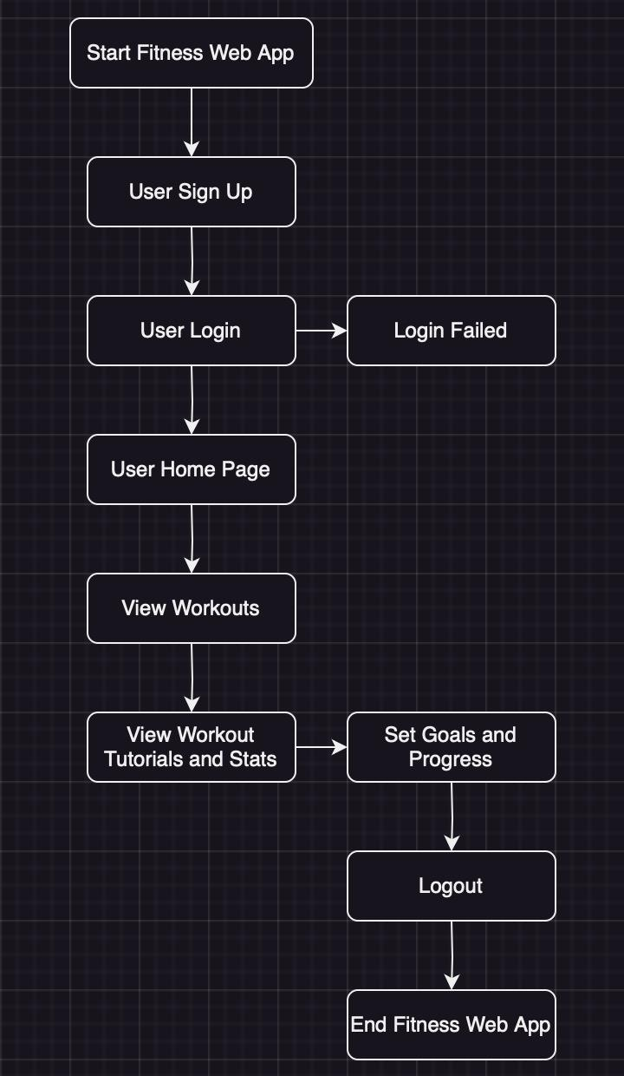

**3.3.2 DATABASE DIAGRAM OF MONGODB:**

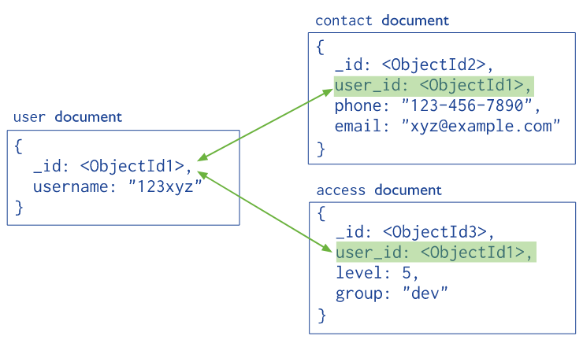

**3.3.3 FLOWCHART**

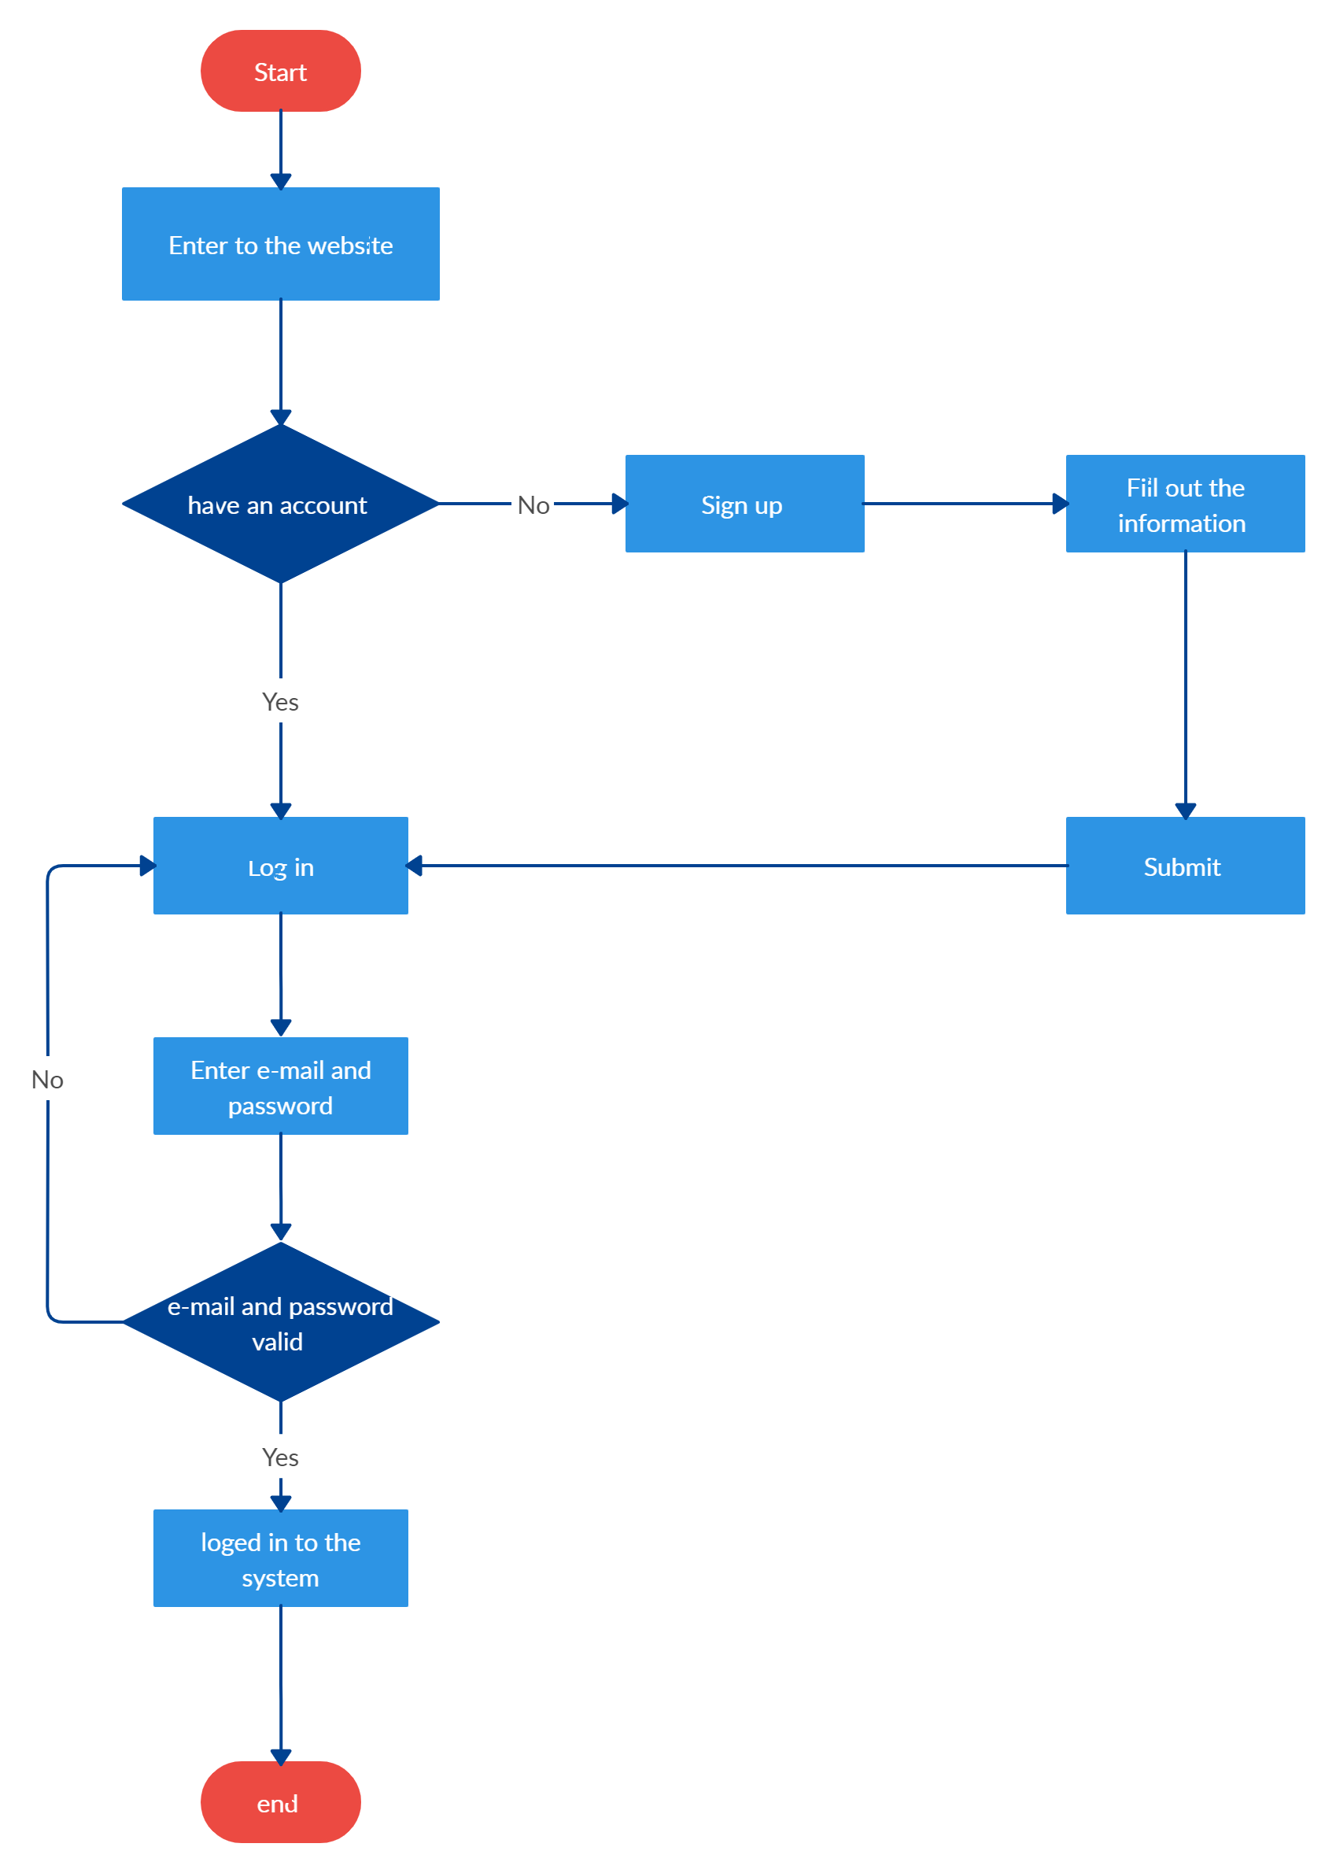

**3.4 API TESTER**

**3.41 RapidAPI (Exercisedb) :**

API (Application Programming Interface) in webpage development refers to a set of rules and protocols that allows different software applications to communicate and interact with each other. In the context of webpage development, APIs are used to integrate and interact with external services, databases, or systems to fetch or manipulate data dynamically.

Here are some common use cases and benefits of using APIs in webpage development:

1. Data Retrieval: APIs enable web developers to retrieve data from external sources, such as databases, web services, or social media platforms. For example, a webpage may use an API to fetch weather data from a weather service to display real-time weather information on the webpage.
2. Data Manipulation: APIs allow developers to manipulate data obtained from external sources before displaying it on a webpage. This could involve formatting, filtering, or aggregating data based on specific requirements or user input.
3. Third-Party Integrations: APIs facilitate integration with third-party services or platforms, enabling developers to incorporate functionalities into their webpages seamlessly. Examples include integrating payment gateways, social media sharing, maps, or analytics services into a webpage.
4. Interactive Features: APIs can power interactive features on webpages, such as real-time chat, live updates, or collaborative editing. By using APIs for communication and data synchronization, webpages can provide dynamic and engaging user experiences.
5. Mobile App Integration: APIs are crucial when developing webpages that interact with mobile applications. Webpages can leverage APIs to communicate with mobile apps, enabling seamless data exchange and synchronization between the web and mobile platforms.
6. Authentication and User Management: APIs play a vital role in authentication and user management systems. Developers can use APIs to integrate authentication services, such as OAuth or JWT, allowing users to log in, register, and access protected resources on a webpage.
7. Content Management Systems (CMS): Many CMS platforms provide APIs that allow developers to retrieve and manipulate content stored in the CMS. This enables developers to create custom webpages that dynamically fetch and display content from a CMS.
8. Custom Functionality: APIs provide flexibility for developers to create custom functionalities and services specific to their webpage's requirements. By designing and exposing their own APIs, developers can create reusable components or services that can be integrated across different webpages or projects.

When utilizing APIs in webpage development, developers typically interact with APIs through HTTP requests, sending requests to specific endpoints and receiving responses in a predefined data format, such as JSON or XML. Popular web technologies, such as JavaScript and frameworks like React or Vue.js, provide libraries and tools to facilitate API integration and data handling in webpage development.

Overall, APIs empower web developers to extend the functionality and capabilities of their webpages by seamlessly integrating with external services, accessing data in real-time, and creating interactive and dynamic user experiences.

RapidAPI is a platform that simplifies API integration for developers by providing a centralized marketplace for a wide range of APIs. It acts as a hub where developers can discover, subscribe to, and manage various APIs, making it easier to incorporate third-party services and functionalities into their applications.

Key Features of RapidAPI:

1. API Marketplace: RapidAPI hosts a vast marketplace with thousands of APIs from different categories, including social media, payments, weather, mapping, machine learning, and more. Developers can browse through the marketplace and find APIs that meet their specific needs.
2. Unified API Management: RapidAPI offers a unified interface to manage multiple APIs. It provides tools to handle authentication, request/response management, API key management, and monitoring, allowing developers to streamline API integration and management tasks.
3. API Testing and Documentation: RapidAPI provides a testing console and documentation for each API listed on its platform. Developers can make test API calls, view sample code snippets, and access comprehensive documentation to understand the API's functionality and usage.
4. Billing and Usage Tracking: RapidAPI facilitates billing and usage tracking for subscribed APIs. It offers transparent pricing models, allowing developers to track their API usage and manage their subscription plans efficiently.
5. SDKs and Code Libraries: RapidAPI offers SDKs (Software Development Kits) and code libraries for popular programming languages, making it easier for developers to integrate APIs into their applications. These SDKs often provide pre-built functions and methods that abstract away the complexities of API communication.
6. Community and Support: RapidAPI fosters a community of developers where users can ask questions, share experiences, and collaborate on API integration projects. It provides forums, chat support, and documentation to assist developers in their API integration journey.
7. RapidAPI for Teams: RapidAPI offers a collaborative environment for teams working on API integration projects. It provides features like team management, role-based access control, and collaboration tools to enhance teamwork and productivity.
8. Serverless Integration: RapidAPI supports serverless architectures by providing serverless functions that can be deployed and executed on demand. This enables developers to build serverless applications using APIs from the RapidAPI marketplace.

RapidAPI serves as a valuable resource for developers looking to enhance their applications with third-party services and functionalities. By offering a wide range of APIs, streamlined integration processes, and comprehensive management tools, RapidAPI simplifies the API integration journey and accelerates the development process.

**3.5 VS code as an Editor:**

An open-source, free code editor created by Microsoft is called Visual Studio Code, or VS Code. It is readily available for Windows, macOS, and Linux operating systems and is heavily utilized by developers for a number of different programming languages and frameworks.

Some of the key features of VS Code include:

1. Intellisense: VS Code has sophisticated syntax highlighting, code completion, and error checking, which can aid developers in writing code more quickly and with fewer mistakes.
2. Debugging: Programming language debugging is made possible by the built-in debuggers that VS Code offers for a number of different programming languages.
3. Extensions: VS Code offers a wide range of add-ons that may be used to expand the capability of the programming, including support for different programming languages, frameworks, and tools.
4. Version control: VS Code comes with integrated support for Git, enabling programmers to carry out common version control tasks right from the editor.
5. Integrated terminal: VS Code has an integrated terminal that enables programmers to execute shell commands and scripts right from the editor.
6. Customizable: The editor's interface, keyboard shortcuts, and other features may all be altered by developers to suit their preferences and work processes thanks to VS Code's high degree of customizability.

All things considered, VS Code is a strong and adaptable code editor that can be used for a variety of programming jobs. It is a popular alternative for developers of all skill levels thanks to its robust feature set, huge extension ecosystem, and customization capabilities.

**4. METHODOLOGY OF THE PURPOSED SYSTEM**

Creating a fitness website using React, CSS, Node.js, MySQL, and APIs involves several steps:

**1. Planning and Design:**

- Identifying the goals and requirements of the fitness website.

- Planning the features, functionality, and layout of the website.

- Creating wireframes or mockups to visualize the design.

**2. Set up the Development Environment:**

- Installing Node.js and set up a development environment on machine.

- Create a new React project using tools like Create React App.

- Set up a MySQL database for storing fitness-related data.

First we install node.js from the internet then install React in the VS Code Terminal; using the following code:

npx create-react-app ./

After the installation of the React framework, we then proceed to install the essential dependencies that is required for the proper execution of our front-end code.

Following dependencies are used during the project (Package.JSON):

"dependencies": {

"@emotion/react": "^11.9.0",

"@emotion/styled": "^11.8.1",

"@mui/icons-material": "^5.6.1",

"@mui/material": "^5.6.1",

"react": "^18.0.0",

"react-dom": "^18.0.0",

"react-horizontal-scrolling-menu": "^2.7.1",

"react-loader-spinner": "^6.0.0-0",

"react-router-dom": "^6.3.0",

"react-scripts": "5.0.1"

Then we proceed to install the required dependencies using the following code:

npm install --legacy-peer-deps

**3. Frontend Development:**

- Start building the user interface using React components.

- Import React Libraries like mui-materials

Components like:

import { Box, Button, Stack, TextField, Typography } from '@mui/material';

- Designing MainBanner and making the home page user-friendly.

- Importing Copyright-Free images to make the website UI- friendly.

- Implementing the page with Search Function and a Horizontal ScrollBar listing various exercises.

- Utilizing CSS or CSS frameworks for styling the components and achieving the desired visual interface.

- Incorporating responsive design principles to ensure the website works well on different devices and aspect ratios.

- Importing **react-router-dom** - a specialized package that is used **only in web-browser-based application development**. It exports **react-router** as a dependency and has additional DOM (document object model) bindings such as <BrowserRouter> and <Link>.

- Implementing ExerciseCards to import the integrated API further down the project.

- Producing a separate page for a specific exercise to provide intricate insight on that exercise.

- Establishing a Footer.

**4. Backend Development:**

- Build a Node.js server to handle backend logic and API requests.

- Implement RESTful APIs for different functionalities, such as user authentication, workout tracking, nutrition logging, etc.

- Connect to the MySQL database using a suitable Node.js MySQL library (e.g., mysql2 or Sequelize).

- Create database models and schema to represent fitness-related data, such as users, workouts, nutrition plans, etc.

- Implement the necessary CRUD operations (Create, Read, Update, Delete) for interacting with the database.

**5. API Integration:**

API integration involves incorporating external APIs into the fitness website to fetch data or access services provided by those APIs. Here is a general approach to API integration:

i. Identifying Suitable APIs:

- Determine the specific functionality or data you need from external APIs for your fitness website. For example, you might want to integrate APIs for exercise databases, youtube search options, etc.

- Research and identify APIs that provide the desired functionality or data. Consider factors such as documentation, reliability, availability, and any usage limitations or costs.

ii. Obtaining API Keys or Authentication Tokens:

- Register for API keys or authentication tokens from the respective API providers. This typically involves creating an account on their developer portal or following their registration process.

- API keys or tokens are usually required to authenticate your requests and track your API usage.

iii. Reading API Documentation:

- Understand the API documentation provided by the API provider. The documentation will outline the available endpoints, request/response formats, authentication methods, rate limits, and any specific requirements or constraints.

- Pay attention to any usage limits or restrictions to ensure you comply with them.

iv. Making API Requests:

- Determine the appropriate places in your code (frontend or backend) where you need to make API calls.

- Use libraries like Axios or Fetch to make HTTP requests to the API endpoints from your frontend React components or your Node.js server.

- Include the necessary headers, authentication tokens, or API keys in your requests as required by the API provider.

v. Handling API Responses:

- Once you receive a response from the API, handle it appropriately in your code.

- Parse the response data and extract the relevant information you need for your fitness website.

- Consider error handling for cases where the API request fails or returns an error response. Display appropriate error messages to users and handle such situations gracefully.

vi. Update UI or Perform Backend Operations:

- Integrate the fetched data from the API into your React components to update the user interface dynamically.

- Update the backend database or perform necessary backend operations based on the API responses, if required.

vii. Test and Monitor:

- Test your API integration thoroughly to ensure it functions as expected.

- Monitor the API usage and performance to identify any issues or potential improvements.

- Handle any updates or changes to the API by staying up-to-date with the API provider's documentation and versioning.

Remember to adhere to the API provider's terms of service and any usage limitations. Some APIs may have usage restrictions, such as rate limits or specific terms for commercial use.

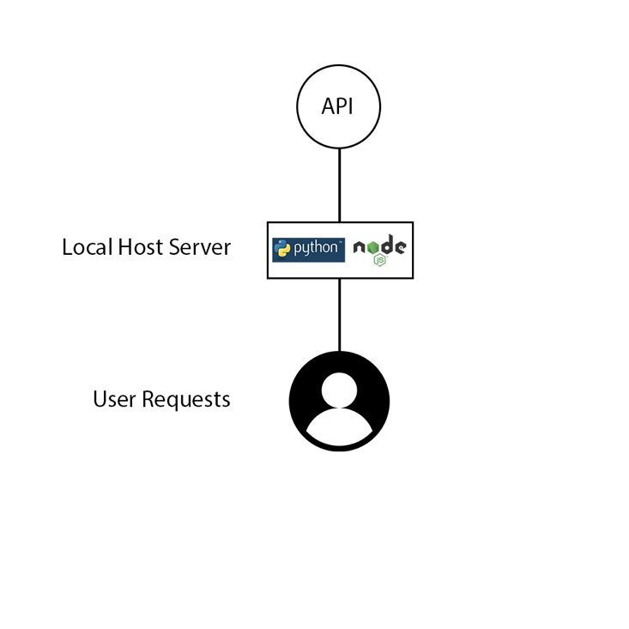

**6. User Authentication:**

- Implement user authentication and authorization using techniques like JWT (JSON Web Tokens) or session-based authentication.

- Allow users to sign up, log in, and manage their profiles securely.

**7. Testing and Debugging:**

- Perform testing at different stages of development to ensure functionality and identify any bugs or issues.

- Use debugging tools and techniques to troubleshoot problems during development.

**8. Deployment:**

- Optimize and bundle your frontend React code for production.

- Set up a production-ready server environment like Netlify.

- Deploy your Node.js server and frontend code to a hosting provider or cloud platform.

- Configure any necessary environment variables or deployment settings.

**9. Ongoing Maintenance and Updates:**

- Monitor the website's performance, security, and guide feedback.

- Regularly update dependencies and libraries to ensure the latest security patches and bug fixes.

- Continuously improve and add new features based on guide feedback.

This is a high-level methodology, and each step requires further research and implementation details based on specific requirements.

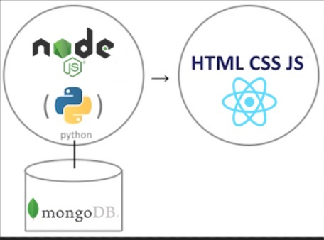

**Fig: 4.1 Connection Diagram**

**5. HARDWARE AND SOFTWARE REQUIREMENTS:**

The hardware requirements for Django, React, Face Recognition, Deepface, and Postman can vary depending on the specific use case and size of the project. However, here are some general hardware recommendations:

1. CPU: At least a dual-core processor with a clock speed of 2.5 GHz or higher. For larger projects or applications with more complex algorithms, a quad-core processor or higher is recommended.
2. RAM: At least 8 GB of RAM, although 16 GB or more is recommended for larger projects.
3. Storage: At least 256 GB of SSD storage is recommended to ensure faster data access and processing speeds.
4. Graphics Card: For face recognition and deep learning applications, a dedicated graphics card is recommended. NVIDIA GPUs with CUDA support are commonly used for these applications.
5. Network: A stable and reliable internet connection is required for React and Django applications, as well as for making API requests using Postman.

It's also worth noting that for running the machine learning models, most of the time the computations will run on servers or in cloud services like AWS, Google Cloud or Azure. So you might only need a system with enough capability to develop and test the application in a proper way.

Additionally, it's important to have a good development environment set up, including a code editor or integrated development environment (IDE) such as Visual Studio Code or Android Studio, as well as the Flutter SDK and any necessary dependencies for the machine learning models you plan to use.

Also, having a good internet connection is important because you will be working with cloud services and you will be downloading packages and libraries required for your project.

Please let me know if you have any further questions about the PC requirements for developing a machine learning and Flutter application.

1. **IMPLEMENTATION AND CODE:**

**FrontEnd:**

**6.1 Pages:**

1. **Home.js:**

import React, { useState } from 'react';

import { Box } from '@mui/material';

import Exercises from '../components/Exercises';

import SearchExercises from '../components/SearchExercises';

import HeroBanner from '../components/HeroBanner';

const Home = () => {

const [exercises, setExercises] = useState([]);

const [bodyPart, setBodyPart] = useState('all');

return (

<Box>

<HeroBanner />

<SearchExercises setExercises={setExercises} bodyPart={bodyPart} setBodyPart={setBodyPart} />

<Exercises exercises={exercises} setExercises={setExercises} bodyPart={bodyPart} />

</Box>

);

};

export default Home;

1. **ExerciseDetail.js:**

import React, {useEffect, useState} from 'react'

import { useParams } from 'react-router-dom';

import { Box } from '@mui/material'

import { exerciseOptions, fetchData, youtubeOptions } from '../utils/fetchData';

import Detail from '../components/Detail';

import ExerciseVideos from '../components/ExerciseVideos';

const ExerciseDetail = () => {

const [exerciseDetail, setExerciseDetail] = useState({});

const [exerciseVideos, setExerciseVideos] = useState([])

const { id } = useParams();

useEffect(() => {

const fetchExercisesData = async () => {

const exerciseDbUrl = 'https://exercisedb.p.rapidapi.com';

const youtubeSearchUrl = 'https://youtube-search-and-download.p.rapidapi.com';

const exerciseDetailData = await fetchData(`${exerciseDbUrl}/exercises/exercise/${id}`, exerciseOptions);

setExerciseDetail(exerciseDetailData);

const exerciseVideosData = await fetchData(`${youtubeSearchUrl}/search?query=${exerciseDetailData.name} exercise`, youtubeOptions);

setExerciseVideos(exerciseVideosData.contents);

}

fetchExercisesData();

}, [ id ])

return (

<Box>

<Detail exerciseDetail = {exerciseDetail}/>

<ExerciseVideos exerciseVideos={exerciseVideos} name={exerciseDetail.name}/>

</Box>

)

}

export default ExerciseDetail

**6.2 Components:**

1. **HeroBanner.js:**

import React from 'react';

import { Box, Stack, Typography } from '@mui/material';

import HeroBannerImage from '../assets/images/banner.png';

const HeroBanner = () => (

<Box sx={{ mt: { lg: '212px', xs: '70px' }, ml: { sm: '50px' } }} position="relative" p="20px">

<Typography color="#FF2625" fontWeight="600" fontSize="26px">Fitness Club</Typography>

<Typography fontWeight={700} sx={{ fontSize: { lg: '44px', xs: '40px' } }} mb="23px" mt="30px">

Sweat, Smile <br />

And Repeat

</Typography>

<Typography fontSize="22px" fontFamily="Alegreya" lineHeight="35px">

Check out the most effective exercises personalized to you

</Typography>

<Stack>

<a href="#exercises" style={{ marginTop: '45px', textDecoration: 'none', width: '200px',

textAlign: 'center', background: '#FF2625', padding: '14px', fontSize: '22px', textTransform: 'none',

color: 'white', borderRadius: '4px' }}>Explore Exercises</a>

</Stack>

<Typography fontWeight={600} color="#FF2625" sx={{ opacity: '0.1', display: { lg: 'block', xs: 'none' }, fontSize: '200px' }}>

Exercise

</Typography>

<img src={HeroBannerImage} alt="hero-banner" className="hero-banner-img" />

</Box>

);

export default HeroBanner;

1. **Navbar.js:**

import React from 'react';

import { Link } from 'react-router-dom';

import { Stack } from '@mui/material';

import Logo from '../assets/images/Logo.png';

const Navbar = () => (

<Stack direction="row" justifyContent="space-around" sx={{ gap: { sm: '123px', xs: '40px' },

mt: { sm: '32px', xs: '20px' }, justifyContent: 'none' }} px="20px">

<Link to="/">

<img src={Logo} alt="logo" style={{ width: '48px', height: '48px', margin: '0px 20px' }} />

</Link>

<Stack

direction="row"

gap="40px"

fontFamily="Alegreya"

fontSize="24px"

alignItems="flex-end"

>

<Link to="/" style={{ textDecoration: 'none', color: '#3A1212', borderBottom: '3px solid #FF2625' }}>Home</Link>

<a href="#exercises" style={{ textDecoration: 'none', color: '#3A1212' }}>Exercises</a>

</Stack>

</Stack>

);

export default Navbar;

1. **SearchExercises.js:**

import React, { useEffect, useState } from 'react';

import { Box, Button, Stack, TextField, Typography } from '@mui/material';

import { exerciseOptions, fetchData } from '../utils/fetchData';

import HorizontalScrollbar from './HorizontalScrollbar';

const SearchExercises = ({ setExercises, bodyPart, setBodyPart }) => {

const [search, setSearch] = useState('');

const [bodyParts, setBodyParts] = useState([]);

useEffect(() => {

const fetchExercisesData = async () => {

const bodyPartsData = await fetchData('https://exercisedb.p.rapidapi.com/exercises/bodyPartList', exerciseOptions);

setBodyParts(['all', ...bodyPartsData]);

};

fetchExercisesData();

}, []);

const handleSearch = async () => {

if (search) {

const exercisesData = await fetchData('https://exercisedb.p.rapidapi.com/exercises', exerciseOptions);

const searchedExercises = exercisesData.filter(

(exercise) => exercise.name.toLowerCase().includes(search)

|| exercise.target.toLowerCase().includes(search)

|| exercise.equipment.toLowerCase().includes(search)

|| exercise.bodyPart.toLowerCase().includes(search),

);

window.scrollTo({ top: 1800, left: 100, behavior: 'smooth' });

setSearch('');

setExercises(searchedExercises);

}

};

return (

<Stack alignItems="center" mt="37px" justifyContent="center" p="20px">

<Typography fontWeight={700} sx={{ fontSize: { lg: '44px', xs: '30px' } }} mb="49px" textAlign="center">

Awesome Exercises You <br/> Should Know

</Typography>

<Box position="relative" mb="72px">

<TextField

height="76px"

sx={{ input: { fontWeight: '700', border: 'none', borderRadius: '4px' },

width: { lg: '1170px', xs: '350px' }, backgroundColor: '#fff', borderRadius: '40px' }}

value={search}

onChange={(e) => setSearch(e.target.value.toLowerCase())}

placeholder="Search Exercises"

type="text"

/>

<Button className="search-btn" sx={{ bgcolor: '#FF2625', color: '#fff', textTransform: 'none',

width: { lg: '173px', xs: '80px' }, height: '56px', position: 'absolute', right: '0px',

fontSize: { lg: '20px', xs: '14px' } }} onClick={handleSearch}>

Search

</Button>

</Box>

<Box sx={{ position: 'relative', width: '100%', p: '20px' }}>

<HorizontalScrollbar data={bodyParts} bodyParts setBodyPart={setBodyPart} bodyPart={bodyPart} isBodyParts/>

</Box>

</Stack>

);

};

export default SearchExercises;

**6.3 Utils:**

* **fetchData.js:**

// connection with Rapid Api

export const exerciseOptions = {

method: 'GET',

headers: {

'X-RapidAPI-Host': 'exercisedb.p.rapidapi.com',

'X-RapidAPI-Key': process.env.REACT_APP_RAPID_API_KEY

},

};

export const youtubeOptions = {

method: 'GET',

headers: {

'X-RapidAPI-Key': process.env.REACT_APP_RAPID_API_KEY ,

'X-RapidAPI-Host': 'youtube-search-and-download.p.rapidapi.com'

}

};

export const fetchData = async (url, options) => {

const res = await fetch(url, options);

const data = await res.json();

return data;

}

1. **HorizontalScrollbar.js:**

import React, { useContext } from 'react'

import { Box, Typography } from '@mui/material';

import { ScrollMenu, VisibilityContext } from 'react-horizontal-scrolling-menu';

import BodyPart from './BodyPart';

import ExerciseCard from './ExerciseCard';

import RightArrowIcon from '../assets/icons/right-arrow.png';

import LeftArrowIcon from '../assets/icons/left-arrow.png';

const LeftArrow = () => {

const { scrollPrev } = useContext(VisibilityContext);

return (

<Typography onClick={() => scrollPrev()} className="right-arrow">

<img src={LeftArrowIcon} alt="right-arrow" />

</Typography>

);

};

const RightArrow = () => {

const { scrollNext } = useContext(VisibilityContext);

return (

<Typography onClick={() => scrollNext()} className="left-arrow">

<img src={RightArrowIcon} alt="right-arrow" />

</Typography>

);

};

const HorizontalScrollbar = ({ data, bodyPart, setBodyPart, isBodyParts }) => {

return (

<ScrollMenu LeftArrow={LeftArrow} RightArrow={RightArrow}>

{data.map((item) => (

<Box

key = {item.id || item}

itemId = {item.id || item}

title = {item.id || item}

m = "0 40px"

>

{isBodyParts ? <BodyPart item = {item} bodyPart = {bodyPart} setBodyPart = {setBodyPart} />

: <ExerciseCard exercise={item} />}

</Box>

)

)}

</ScrollMenu>

)

}

export default HorizontalScrollbar

1. **BodyPart.js:**

import React from 'react'

import { Stack, Typography } from '@mui/material';

import Icon from '../assets/icons/gym.png'

const BodyPart = ({ item, setBodyPart, bodyPart }) => {

return (

<Stack

type= 'button'

alignItems= 'center'

justifyContent= 'center'

className= 'bodyPart-card'

sx= {{

borderTop: bodyPart === item ? '4px solid #ff2625' : '',

borderBottomLeftRadius: '20px',

width: '270px',

height: '280px',

cursor: 'pointer',

gap: '47px'

}}

onClick = { () => {

setBodyPart(item);

window.scrollTo({top: 1800, left: 100, behavior : 'smooth'})

}}

>

<img src={Icon} alt="dumbbell" style={{ width: '40px', height: '40px'}} />

<Typography fontSize="24px" fontweight="bold" color="#3A1212" textTransform= 'capitalize'

>

{item}

</Typography>

</Stack>

)

}

export default BodyPart

1. **Exercises.js:**

import React, { useEffect, useState } from 'react';

import Pagination from '@mui/material/Pagination';

import { Box, Stack, Typography } from '@mui/material';

import { exerciseOptions, fetchData } from '../utils/fetchData';

import ExerciseCard from './ExerciseCard';

const Exercises = ({ exercises, setExercises, bodyPart }) => {

const [currentPage, setCurrentPage] = useState(1);

const exercisesPerPage = 9;

const indexOfLastExercise = currentPage * exercisesPerPage;

const indexOfFirstExercise = indexOfLastExercise - exercisesPerPage;

const currentExercises = exercises.slice(indexOfFirstExercise, indexOfLastExercise)

const paginate = (e, value) => {

setCurrentPage(value);

window.scrollTo({ top: 1800, beahvior: 'smooth'})

}

// Now we show the exercises on clicking the categories

useEffect(() => {

const fetchExercisesData = async () => {

let exercisesData = [];

if (bodyPart === 'all') {

exercisesData = await fetchData('https://exercisedb.p.rapidapi.com/exercises',

exerciseOptions);

}

else {

exercisesData = await fetchData(`https://exercisedb.p.rapidapi.com/exercises/bodyPart/${bodyPart}`,

exerciseOptions);

}

setExercises(exercisesData);

}

fetchExercisesData();

}, [bodyPart]);

return (

<Box id = 'exercises'

sx = {{mt: { lg: '110px'}}}

mt = '50px'

p='20px'

>

<Typography variant = 'h3' mb = '46px'>

Showing Results For

</Typography>

<Stack direction = 'row' sx = {{ gap: { lg: '110px', xs: '50px'}}}

flexWrap = 'wrap' justifyContent = 'center'>

{currentExercises.map((exercise, index) => (

<ExerciseCard key={index} exercise = {exercise} />

))}

</Stack>

<Stack sx={{ mt: { lg: '114px', xs: '70px' } }} alignItems="center">

{exercises.length > 9 && (

<Pagination

color="standard"

shape="rounded"

defaultPage={1}

count={Math.ceil(exercises.length / exercisesPerPage)}

page={currentPage}

onChange={(paginate)}

size="large"

/>

)}

</Stack>

</Box>

)

}

export default Exercises

1. **ExerciseCard.js:**

import React from 'react'

import { Link } from 'react-router-dom';

import { Button, Stack, Typography } from '@mui/material';

const ExerciseCard = ({ exercise }) => {

return (

<Link className= 'exercise-card' to = {`/exercise/${exercise.id}`}>

< img src = {exercise.gifUrl} alt = {exercise.name} Loading = 'lazy' />

<Stack direction = 'row'>

<Button sx = {{ ml: '21px', color: '#fff', background: '#ffa9a9',

fontSize: '14px', borderRadius: '20px', textTransform: 'capitalize'}}>

{exercise.bodyPart}

</Button>

<Button sx = {{ ml: '21px', color: '#fff', background: '#fcc757',

fontSize: '14px', borderRadius: '20px', textTransform: 'capitalize'}}>

{exercise.target}

</Button>

</Stack>

<Typography ml = '21px' color = '#000' fontWeight = 'bold' mt = '11px'

pb = '10px' textTransform = 'capitalize' fontSize= '23px'>

{exercise.name}

</Typography>

</Link>

)

}

export default ExerciseCard

1. **Detail.js:**

import React from 'react';

import { Typography, Stack, Button } from '@mui/material';

import BodyPartImage from '../assets/icons/body-part.png';

import TargetImage from '../assets/icons/target.png';

import EquipmentImage from '../assets/icons/equipment.png';

const Detail = ({ exerciseDetail }) => {

const { bodyPart, gifUrl, name, target, equipment } = exerciseDetail;

const extraDetail = [

{

icon: BodyPartImage,

name: bodyPart,

},

{

icon: TargetImage,

name: target,

},

{

icon: EquipmentImage,

name: equipment,

},

];

return (

<Stack gap="60px" sx={{ flexDirection: { lg: 'row' }, p: '20px', alignItems: 'center' }}>

<img src={gifUrl} alt={name} loading="lazy" className="detail-image" />

<Stack sx={{ gap: { lg: '35px', xs: '20px' } }}>

<Typography sx={{ fontSize: { lg: '64px', xs: '30px' } }} fontWeight={700} textTransform="capitalize">

{name}

</Typography>

<Typography sx={{ fontSize: { lg: '24px', xs: '18px' } }} color="#4F4C4C">

Exercises keep you strong.{' '}

<span style={{ textTransform: 'capitalize' }}>{name}</span> is one

of the best <br /> exercises to target your {target}. It will help you improve your{' '}

<br /> mood and gain energy.

</Typography>

{extraDetail?.map((item) => (

<Stack key={item.name} direction="row" gap="24px" alignItems="center">

<Button sx={{ background: '#FFF2DB', borderRadius: '50%', width: '100px', height: '100px' }}>

<img src={item.icon} alt={bodyPart} style={{ width: '50px', height: '50px' }} />

</Button>

<Typography textTransform="capitalize" sx={{ fontSize: { lg: '30px', xs: '20px' } }}>

{item.name}

</Typography>

</Stack>

))}

</Stack>

</Stack>

);

};

export default Detail;

1. **ExerciseVideos.js:**

import React from 'react';

import { Typography, Box, Stack } from '@mui/material';

const ExerciseVideos = ({ exerciseVideos, name }) => {

if(!exerciseVideos.length) return 'Loading...';

return (

<Box sx={{ marginTop: { lg: '203px', xs: '20px' } }} p="20px">

<Typography sx={{ fontSize: { lg: '44px', xs: '25px' } }} fontWeight={700} color="#000" mb="33px">

Watch <span style={{ color: '#FF2625', textTransform: 'capitalize' }}>{name}</span> exercise videos

</Typography>

<Stack sx={{ flexDirection: { lg: 'row' }, gap: { lg: '110px', xs: '0px' } }}

justifyContent="flex-start" flexWrap="wrap" alignItems="center">

{exerciseVideos?.slice(0, 6).map((item, index) => (

<a

key={index}

className="exercise-video"

href={`https://www.youtube.com/watch?v=${item.video.videoId}`}

target="_blank"

rel="noreferrer"

>

<img style={{ borderTopLeftRadius: '20px' }} src={item.video.thumbnails[0].url} alt={item.video.title} />

<Box>

<Typography sx={{ fontSize: { lg: '28px', xs: '18px' } }} fontWeight={600} color="#000">

{item.video.title}

</Typography>

<Typography fontSize="14px" color="#000">

{item.video.channelName}

</Typography>

</Box>

</a>

))}

</Stack>

</Box>

);

};

export default ExerciseVideos;

1. **Loader.js:**

import React from 'react';

import { Stack } from '@mui/material';

import { InfinitySpin } from 'react-loader-spinner';

const Loader = () => (

<Stack direction="row" justifyContent="center" alignItems="center" width="100%">

<InfinitySpin color="black" />

</Stack>

);

export default Loader;

1. **Footer.js:**

import React from 'react';

import { Box, Typography } from '@mui/material';

const Footer = () => (

<Box mt="80px" bgcolor="#FFF3F4">

<Typography variant="h5" sx={{ fontSize: { lg: '28px', xs: '20px' } }}

mt="41px" textAlign="center" pb="40px">Made by Suhail Sajid and Sumiran Chhetri</Typography>

</Box>

);

export default Footer;

**6.4 Package.json:**

**Dependencies used:**

"dependencies": {

"@emotion/react": "^11.9.0",

"@emotion/styled": "^11.8.1",

"@mui/icons-material": "^5.6.1",

"@mui/material": "^5.6.1",

"react": "^18.0.0",

"react-dom": "^18.0.0",

"react-horizontal-scrolling-menu": "^2.7.1",

"react-loader-spinner": "^6.0.0-0",

"react-router-dom": "^6.3.0",

"react-scripts": "5.0.1"

}

**App.js:**

import React from 'react';

import { Route, Routes } from 'react-router-dom';

import { Box } from '@mui/material';

import './App.css';

import ExerciseDetail from './pages/ExerciseDetail';

import Home from './pages/Home';

import Navbar from './components/Navbar';

import Footer from './components/Footer';

const App = () => {

return(

<Box width="400px" sx={{ width: { xl: '1488px' } }} m="auto">

<Navbar />

<Routes>

<Route path="/" element={<Home />} />

<Route path="/exercise/:id" element={<ExerciseDetail />} />

</Routes>

<Footer />

</Box>

)

}

export default App

**Index.js:**

import React from 'react';

import ReactDOM from 'react-dom/client';

import { BrowserRouter } from 'react-router-dom';

import App from './App';

const root = ReactDOM.createRoot(document.getElementById('root'));

root.render(

<React.StrictMode>

<BrowserRouter>

<App />

</BrowserRouter>

</React.StrictMode>,

);

**App.css:**

body {

font-family: 'Josefin Sans';

background-color: #FFFAFB;

}

* {

padding: 0px;

margin: 0px;

box-sizing: border-box;

}

::-webkit-scrollbar {

width: 0px;

}

.right-arrow,

.left-arrow {

cursor: pointer;

background: transparent;

outline: none;

border: none;

display: flex;

justify-content: center;

align-items: center;

color: #FF2625;

font-size: 25px;

border-radius: 4px;

position: absolute;

bottom: -20px;

right: 80px;

transform: scale(1, 1);

transition: 0.3s all ease-in-out;

}

.right-arrow {

right: 140px;

}

.right-arrow:hover,

.left-arrow:hover {

transform: scale(1.3, 1.3);

}

.react-horizontal-scrolling-menu--wrapper {

width: 100%;

display: flex;

flex-wrap: wrap;

}

.detail-image {

width: 729px;

height: 742px;

}

.hero-banner-img {

position: absolute;

right: 40px;

top: 0px;

width: 700px;

height: 900px;

margin-top: -330px;

}

.exercise-card {

width: 400px;

height: 445px;

background: #fff;

border-top: 4px solid #FF2625;

border-bottom-left-radius: 20px;

text-decoration: none;

display: flex;

justify-content: space-between;

flex-direction: column;

padding-bottom: 10px;

transform: scale(1, 1);

transition: 0.3s all ease-in-out;

}

.exercise-card img {

height: 326px;

}

.bodyPart-card {

transform: scale(1, 1);

transition: 0.3s all ease-in-out;

}

.exercise-card:hover,

.bodyPart-card:hover {

transform: scale(1.1, 1.1);

}

.search-btn:hover {

color: #FF2625 !important;

border: 1px solid #FF2625 !important;

}

.exercise-video {

display: flex;

flex-direction: column;

gap: 24px;

width: 387px;

height: 381px;

text-decoration: none;

}

@media screen and (max-width:1200px) {

.detail-image {

width: 300px;

height: 300px;

}

.react-horizontal-scrolling-menu--scroll-container {

width: 500px;

}

.left-arrow,

.right-arrow {

position: static !important;

}

.hero-banner-img {

display: none;

}

.exercise-card {

width: 320px;

.exercise-video {

width: 320px;

height: 300px;

}

}

@media screen and (max-width:400px) {

.exercise-card {

width: 280px;

}

}

**6.5 API SNIPPETS:**

**EXERCISEDB:**

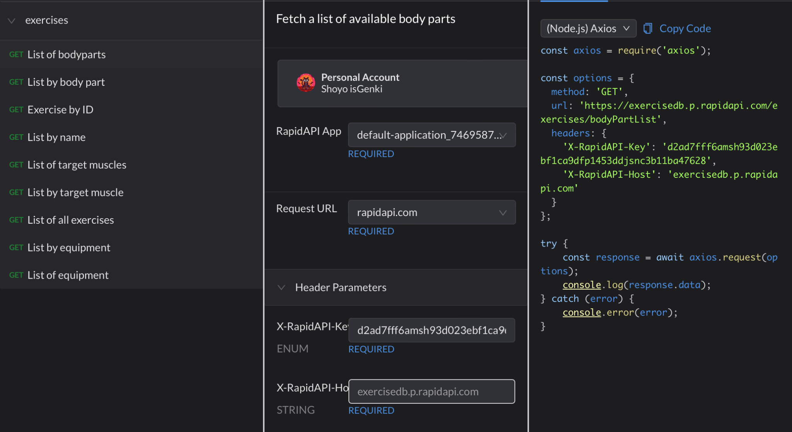

**Youtube-Search-and-Download API:**

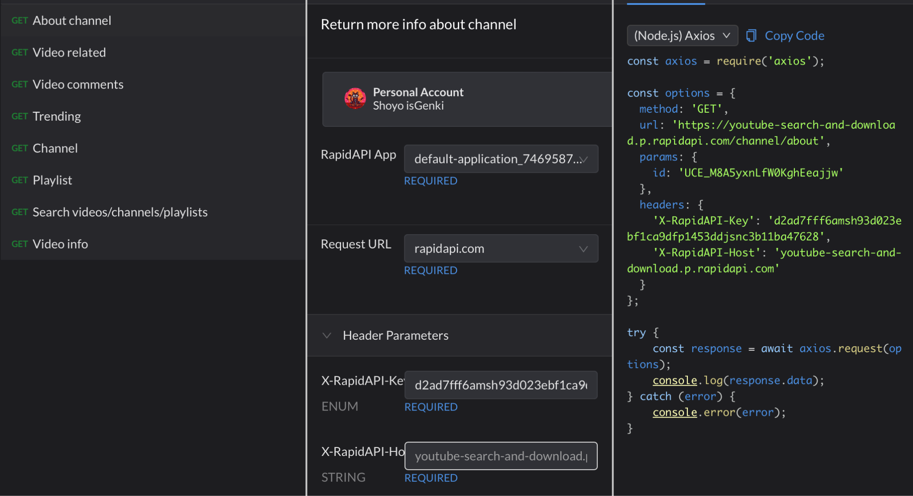

**7. OUTPUTS:**

**7.1 HOMEPAGE:** depicts the landing page or home page of our application, which provides options to redirect users to the login page and exercise page. It serves as the initial interface for users to choose between logging out and seeking exercises.

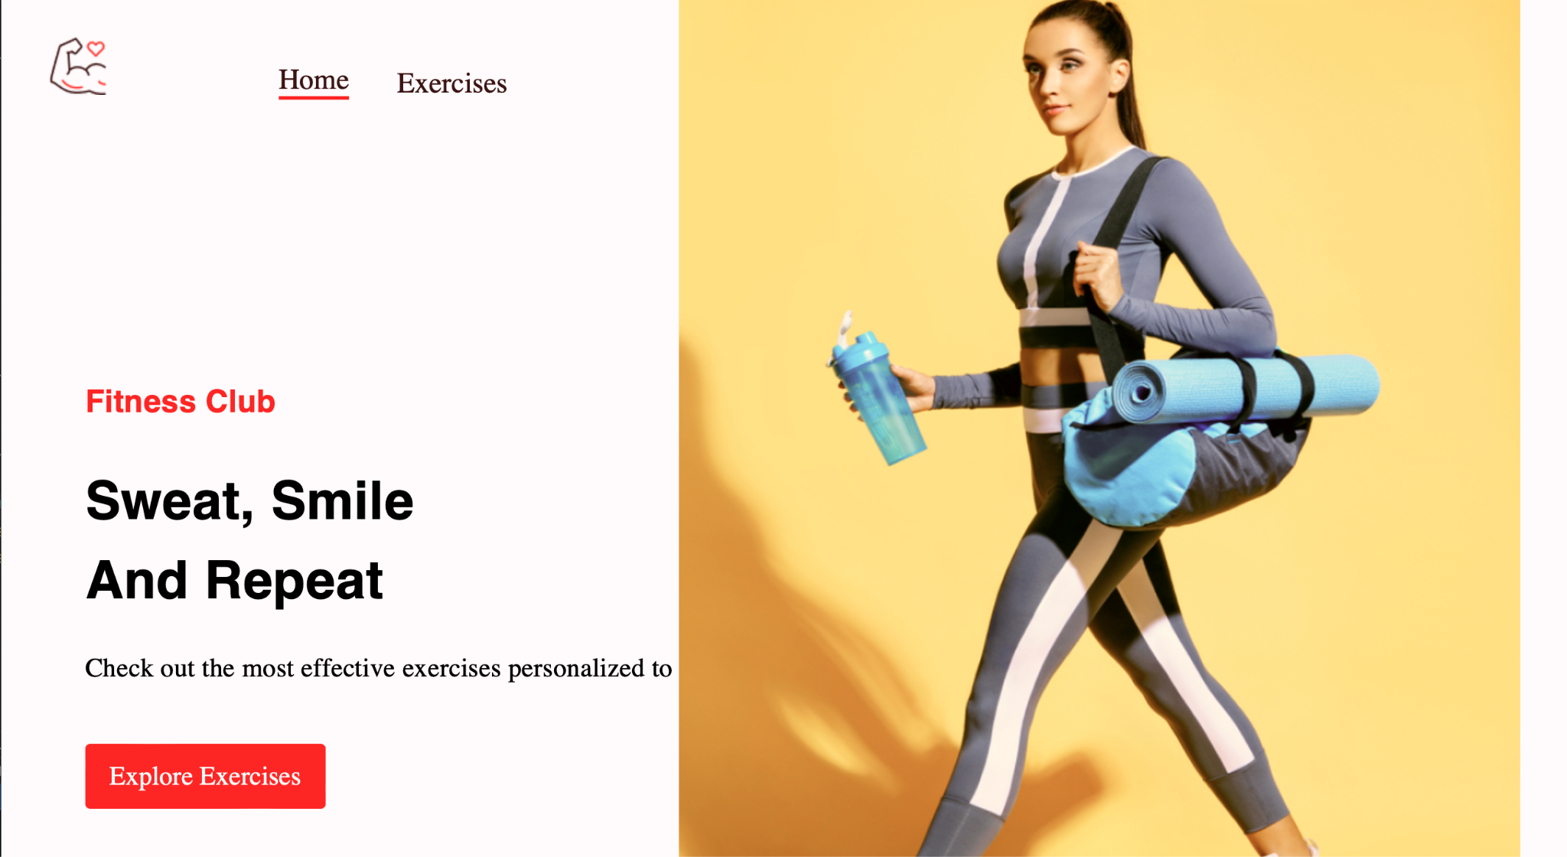

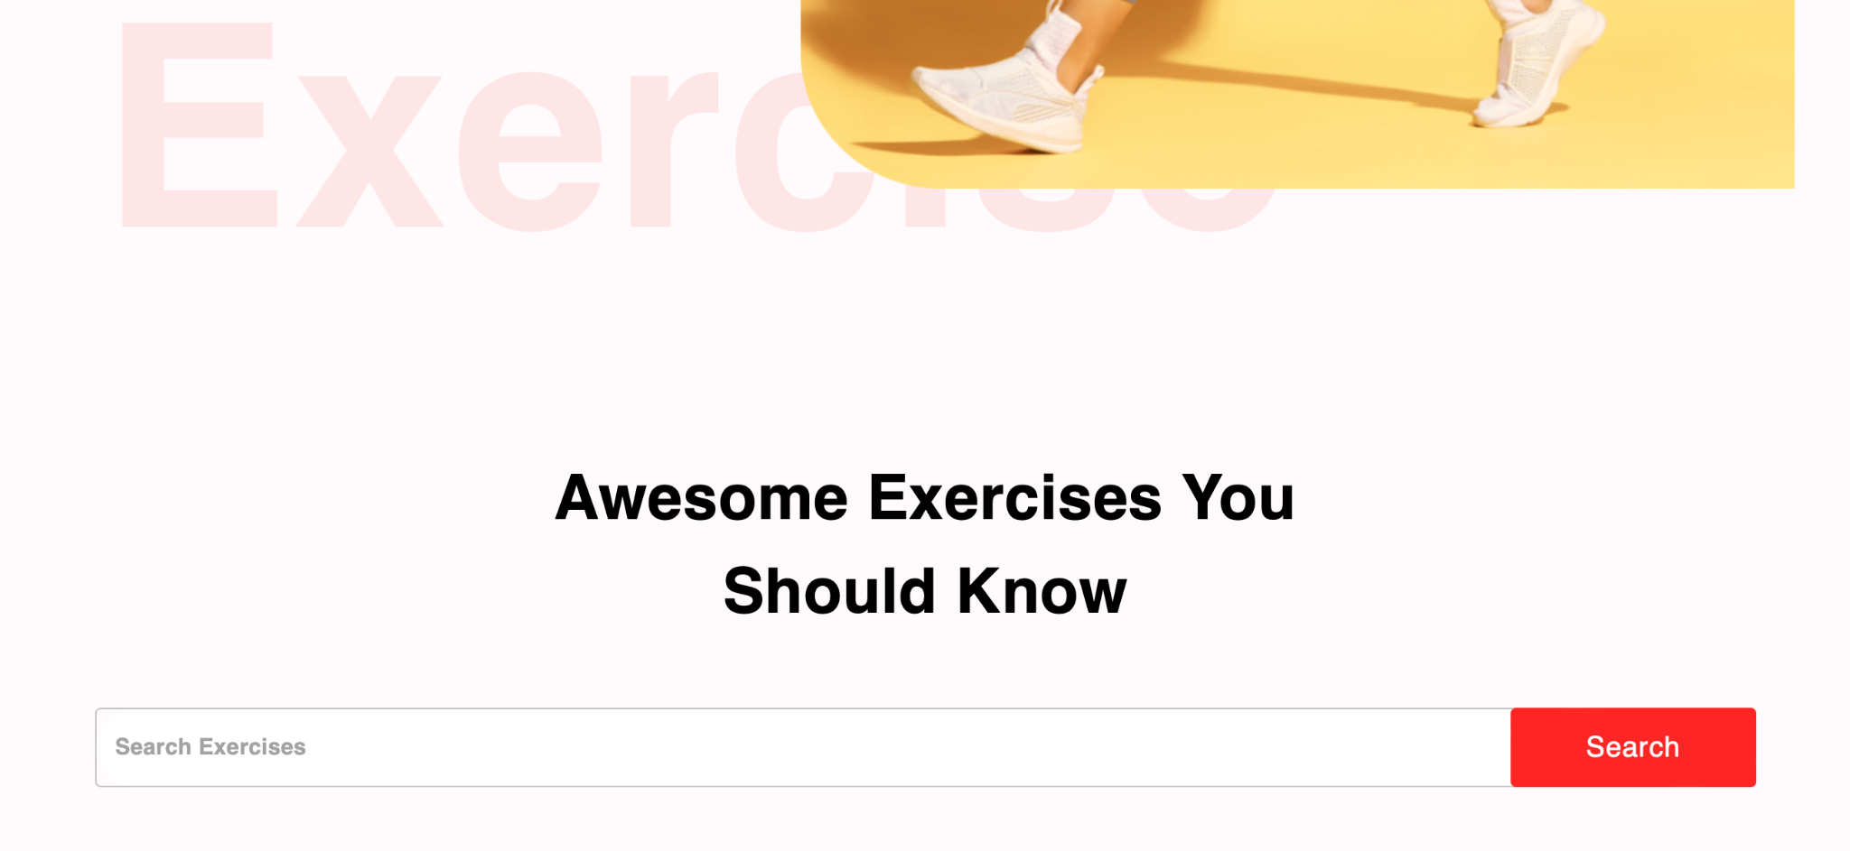

**7.2 SEARCH BAR:** This page represents the section of our application that showcases our exercises and tutorials. It provides a visual representation or a list of the equipments we collaborate with and the range of exercises we provide.

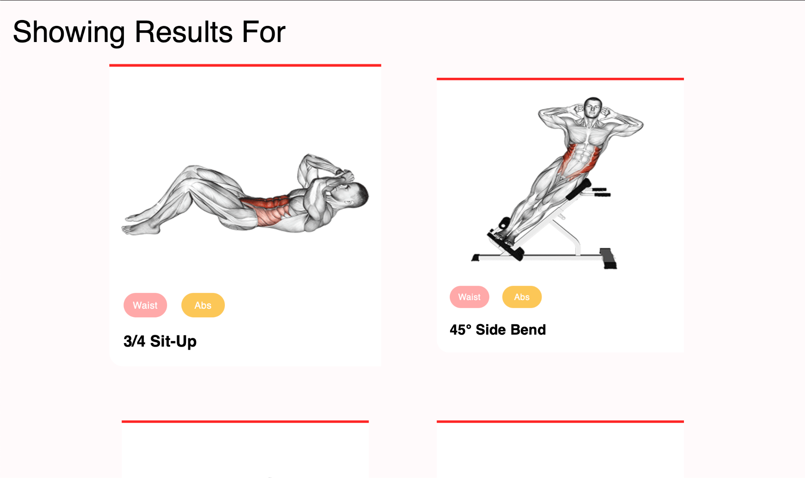

**7.3.1. Exercise Page:** This section represents the section of our application that showcases a certain exercise chosen by the user. It provides a visual representation of that particular exercise. This section aims to highlight the diverse fitness tutorialss we provide to our customers.

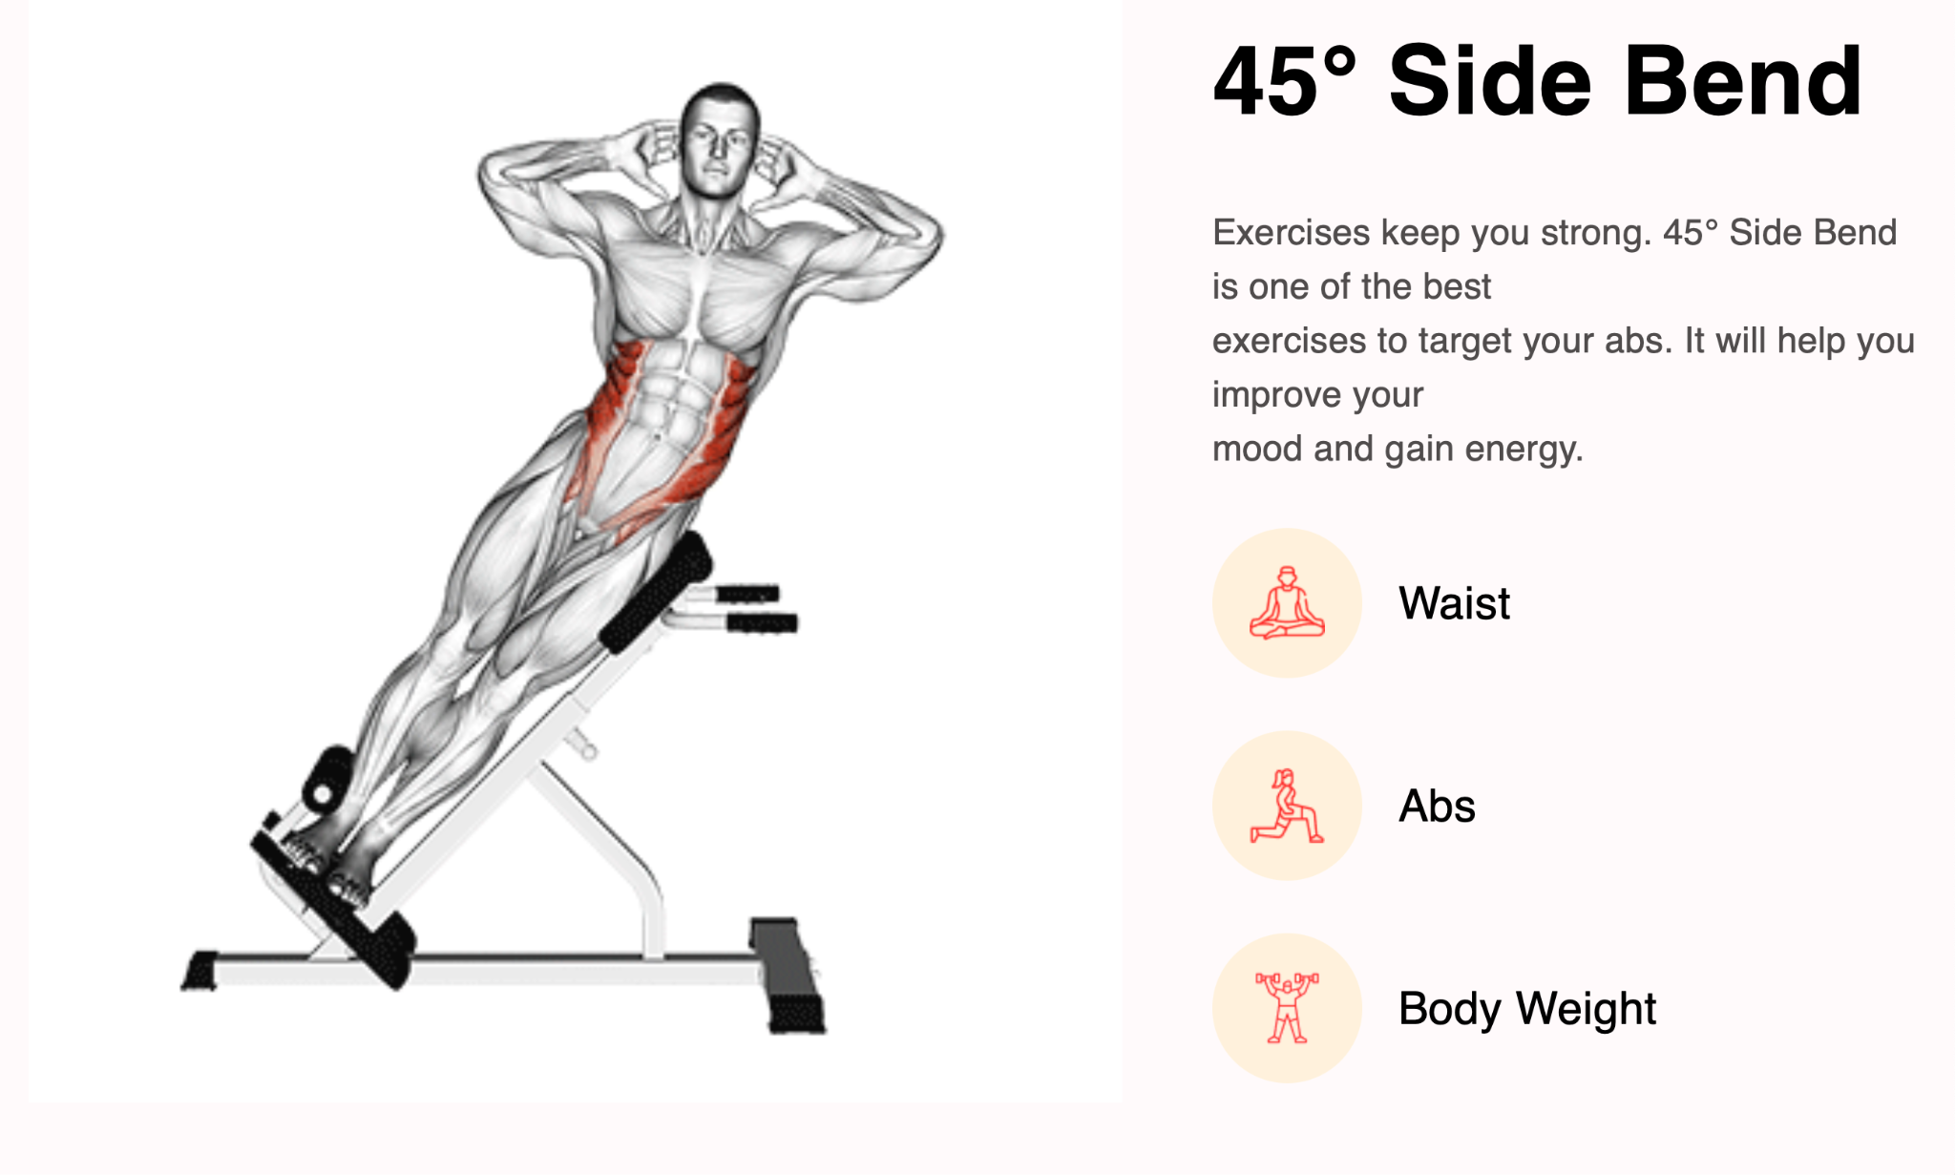

**7.3.2. Watch Respective Exercise Videos:** This page depicts the section where we can connect with YouTube to glance over tutorial videos from various experts.

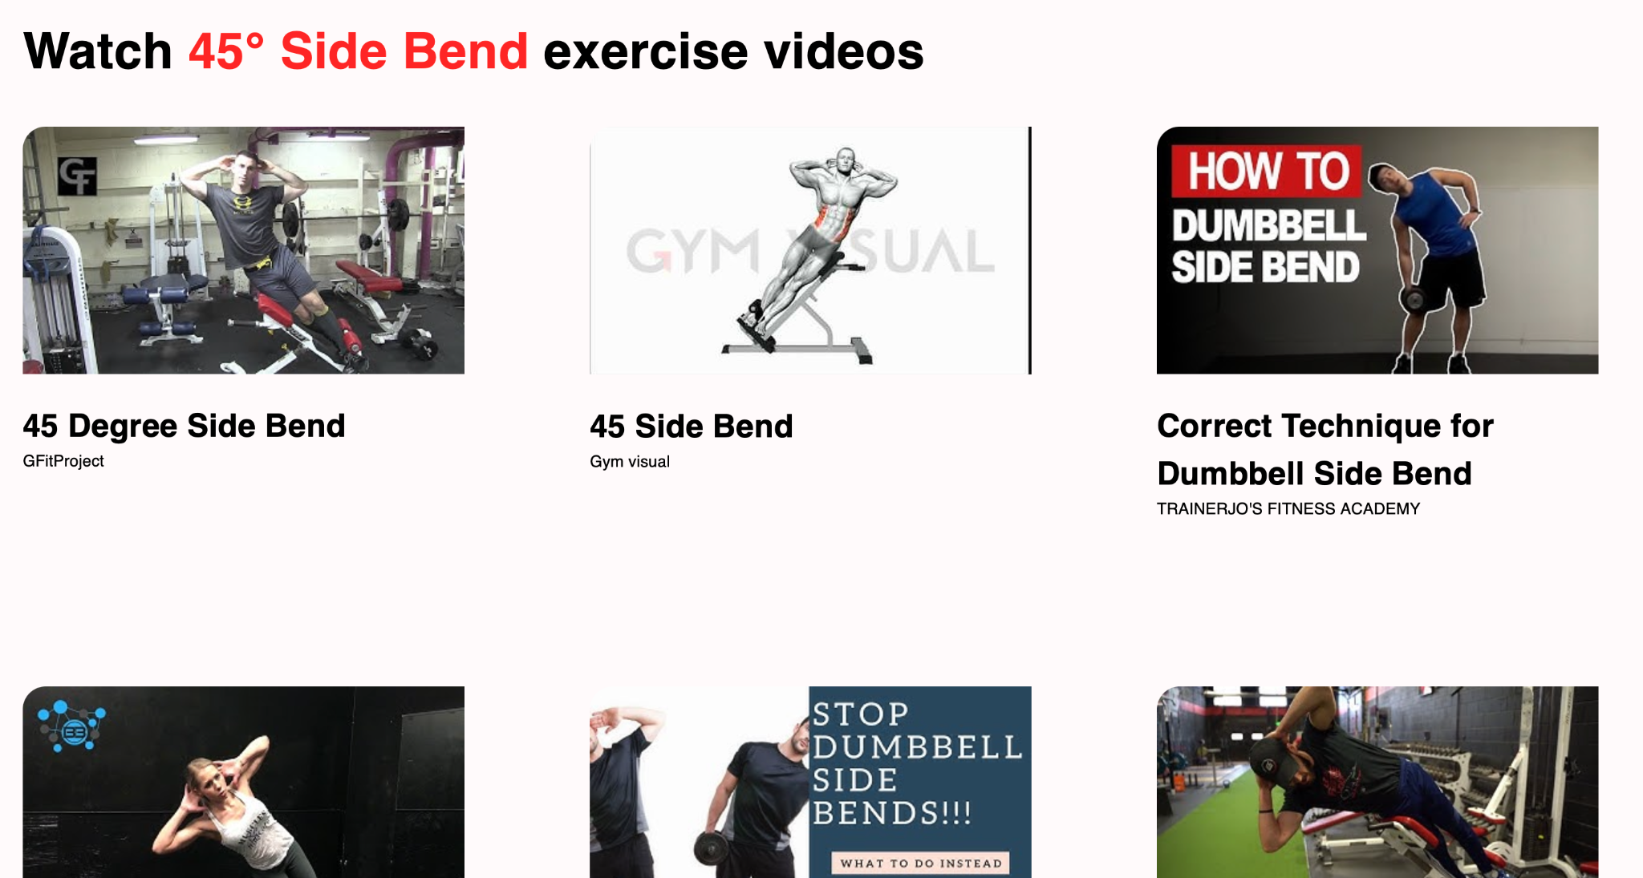

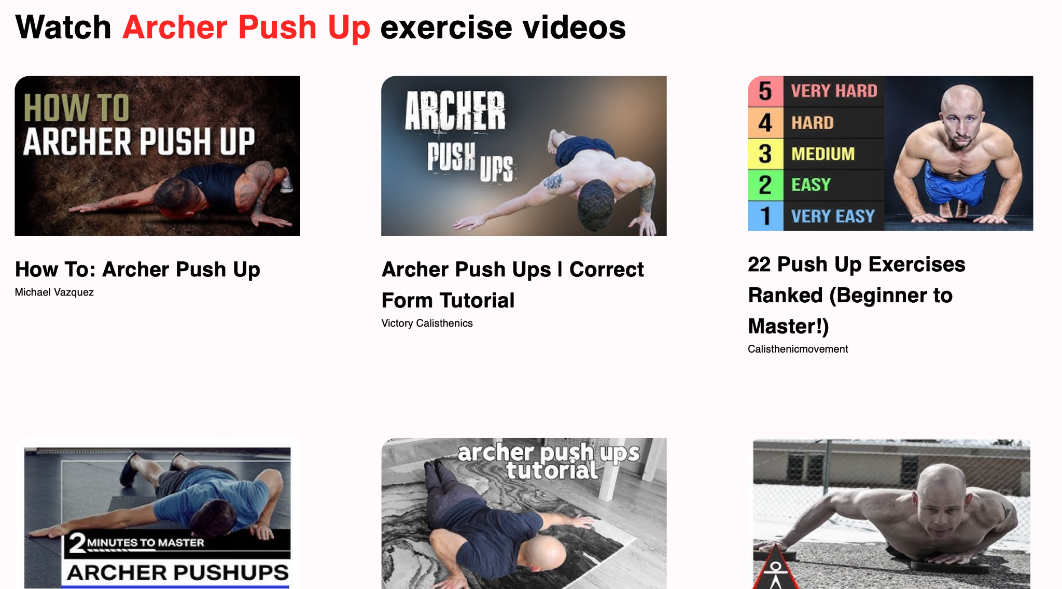

**7.4 Signup/Login Page:** represents the login and authentication feature of our application. This figure illustrates the user interface where users can enter their login credentials, such as username, and password, to access their accounts. Additionally, it can redirect to creating a new account page.

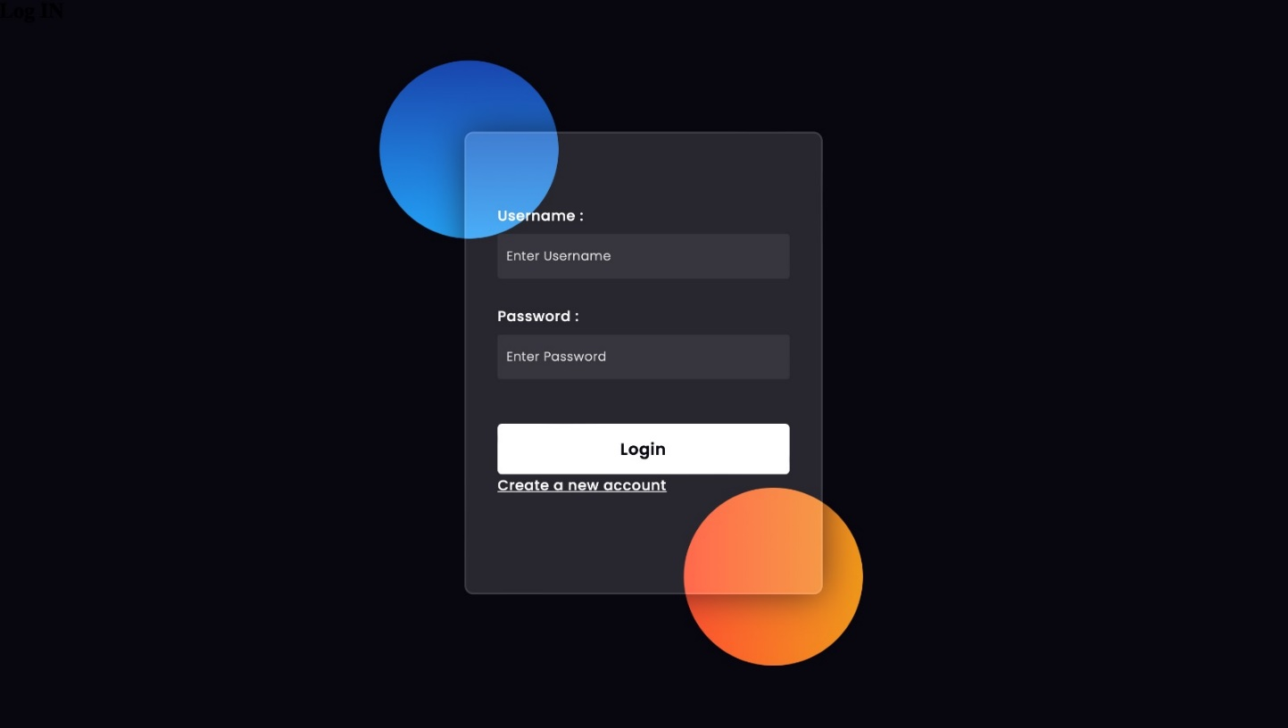

**Future Work**

In the future, fitness websites will likely continue to evolve and offer a wide range of features and services to cater to the needs of their users. Here are some potential future developments and features we might see:

1.Personalized Fitness Plans: Fitness websites will become even more adept at providing personalized workout plans based on individual goals, preferences, and fitness levels. They will leverage advanced algorithms and machine learning techniques to create tailored plans that optimize results for each user.

2.Virtual Personal Trainers: With the advancement of technology, fitness websites might integrate virtual personal trainers that use artificial intelligence and natural language processing to guide users through their workouts. These virtual trainers could provide real-time feedback, correct form, suggest modifications, and motivate users to stay on track.

3.Wearable Device Integration: Fitness websites will likely integrate with a wider range of wearable devices and fitness trackers, allowing users to seamlessly sync their data for tracking progress, monitoring performance, and receiving personalized recommendations based on their activity levels and biometric data.

4.Social Interaction and Community Building: Future fitness websites may focus on building vibrant online fitness communities, where users can connect, share achievements, challenges, and experiences. These platforms will facilitate social interaction through forums, groups, challenges, and live streaming workouts, creating a supportive and motivating environment for users.

5.Nutrition and Meal Planning: Fitness websites will expand their offerings to include comprehensive nutrition and meal planning features. Users will be able to access customized meal plans, nutritional advice, calorie tracking, and even personalized grocery lists. Integration with food delivery services could also simplify the process of acquiring healthy ingredients.

6.Virtual Reality (VR) Fitness: As VR technology advances, fitness websites may incorporate immersive VR workouts, providing users with interactive and engaging exercise experiences. VR fitness can simulate various environments, offer interactive challenges, and make workouts more enjoyable and motivating.

7.Gamification and Rewards: To enhance user engagement and motivation, fitness websites might employ gamification elements such as challenges, achievements, leaderboards, and rewards. These features will encourage users to set goals, track progress, and compete with friends or other community members.

8.Integration with Healthcare Providers: Fitness websites may collaborate with healthcare providers and wellness programs to offer holistic approaches to health and fitness. This integration could involve sharing relevant health data, providing access to telehealth services, and offering specialized programs for individuals with specific medical conditions or goals.

9.Virtual Classes and Workouts: Fitness websites will likely offer a wide range of virtual classes and workouts, covering different fitness disciplines, intensity levels, and durations. Users will have access to on-demand videos, live-streamed sessions, and interactive group workouts, providing flexibility and convenience in their exercise routines.

10.Continuous Learning and Education: Fitness websites may incorporate educational resources such as articles, videos, podcasts, and webinars to help users expand their knowledge about fitness, nutrition, and overall well-being. These resources will empower users to make informed decisions and adopt healthy habits.

**Conclusion**

In conclusion, our fitness website in the future will be a dynamic and comprehensive platform that goes beyond just providing workout routines and exercise tracking. It will incorporate advanced technologies, personalized features, and interactive elements to deliver a holistic fitness experience to its users.

The future fitness website will leverage algorithms and artificial intelligence to create personalized workout plans tailored to individual goals, preferences, and fitness levels. It will integrate with wearable devices and fitness trackers, allowing users to seamlessly track their progress, monitor performance, and receive personalized recommendations based on their activity levels and biometric data.

Social interaction and community building will play a significant role, with fitness websites fostering vibrant online communities where users can connect, share achievements, and support each other. Gamification elements, such as challenges, leaderboards, and rewards, will enhance user engagement and motivation.

**References**

1. <https://react.dev/learn>
2. <https://stackoverflow.com/>
3. <https://mui.com/components/>
4. <https://rapidapi.com/justin-WFnsXH_t6/api/exercisedb/>
5. <https://rapidapi.com/h0p3rwe/api/youtube-search-and-download/>

**Plagiarism Report**